**INSTRUCTIONS ON HOW TO OPERATE THE ROBOT**

**By: Xuan Ky Pham**

**Index:**

1. Starting up the robot
2. Configure Wifi for client PC
3. Operate using PS2 Remote
4. Operate by Web server on ESP32
5. Operate by Webserver on RPI
6. Operate by Python application PY3.11 with PYQT6, Display camera
7. Operate By Python Application with the Flask Web Framework, Display camera.
8. How to change the Maximum Speed of Nicobot
9. How to Disable / Enable FWD and AFT Ultrasonic Sensor
10. How to Stop a Robot Car Emergency
11. How to Charge the Battery
12. How to operate the MIT app
13. How to setup wifi for ESP32 controller
14. How to clear wifi for ESP32 controller

**1. Starting up the Robot**

* **Switch on the** main power switch inside the control panel. After 1 minute, press the reset button to restart ESP32**.** (Why do we need to reset? because ESP32 starts faster than the Wifi Router and RPI, when powered on, ESP32 cannot find Wifi and Mqtt Broker, it will automatically go to Wifi Setting Mode. All the LED lights in front of Nicobot are off. The user needs to press the reset button after 1 minute until the indicator LED is ON.

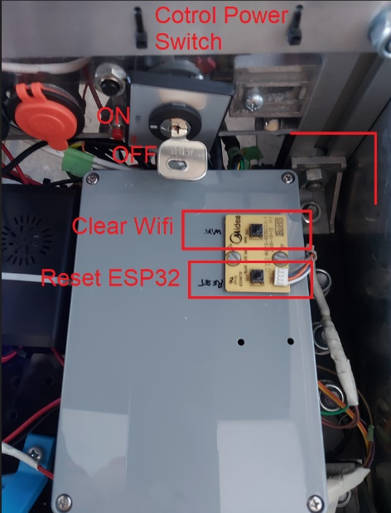

* **Switch ON** Motor battery power, positioned near the aft battery charger.

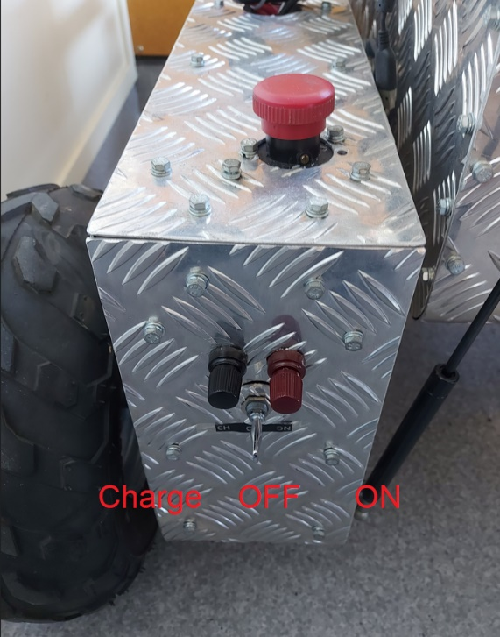

* Confirm the LED indicator Red is ON, others LED is OFF. Startup completed.

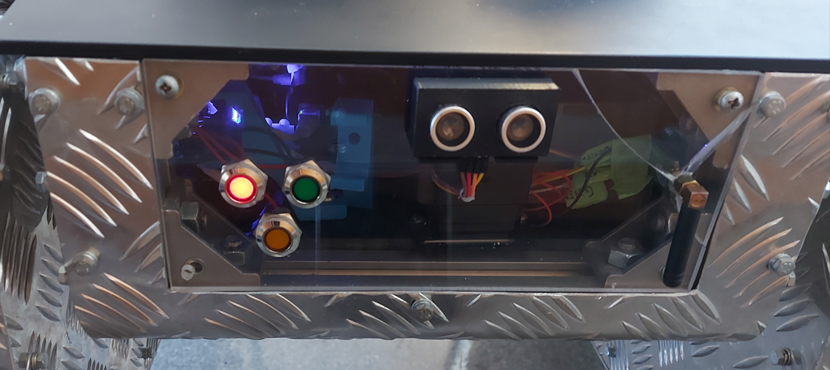

**Now Nicobot is ready to start**

*Note: Yellow LED light is on when MQTT Broker fail or Wifi Fail*

**2. Config Wifi for PC or Smartphone**

Robot Car wifi:

**User : RobotCar24g**

**Password: robotcarky**

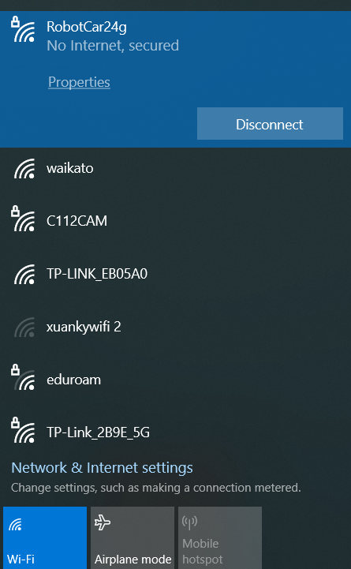

**3. Operate using PS2 Remote**

Press the Start Button on Remote 2 times, check that the Green LED Light is ON, and the Yellow and Red are OFF. Nicobot is ready to start. (Why press 2 times? Because the Remote is normally in sleep mode to save battery energy, press 1 to wake up the remote, then second time to activate the remote, ready to operate.

To Disable or Deactivate remote operation, press the SELECT button on the remote

Control by Joystick:

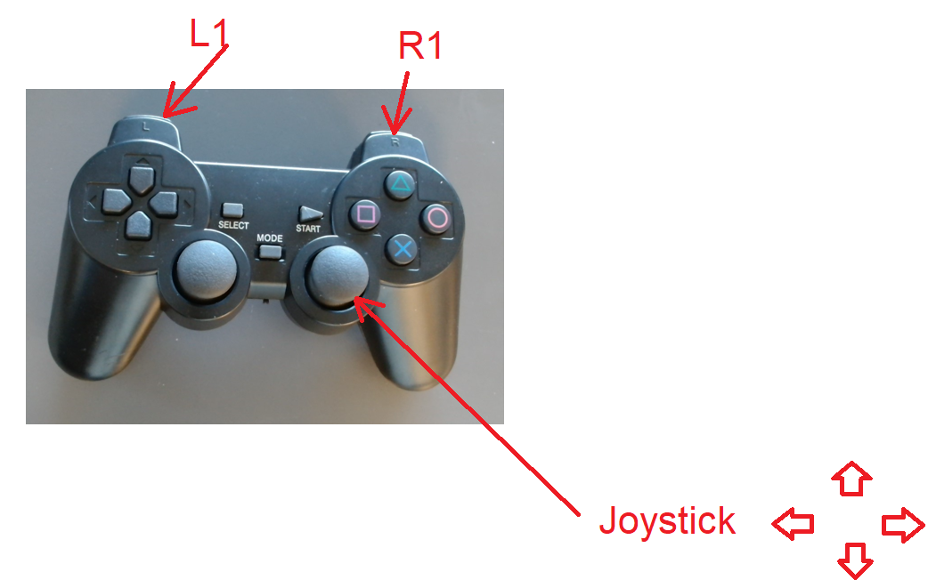

Press and hold the L1 or R1 Button, then move the Joystick 4 positions. Motor Speed will be automatically adjusted by how much the joystick moves.

Note: Max motor speed is limited for safety when used in the LAB or a narrow area. To change the Max Motor Speed 0- 255 user just opens the Android application or the Web page to change. **See section 7**.

Digital Control:

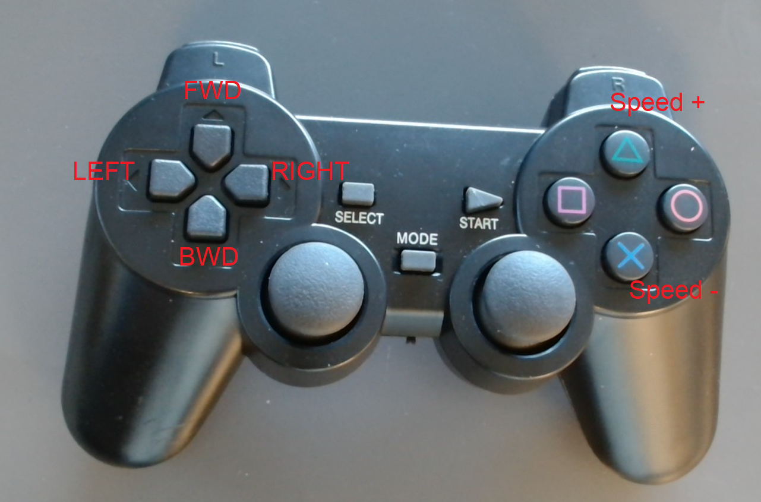

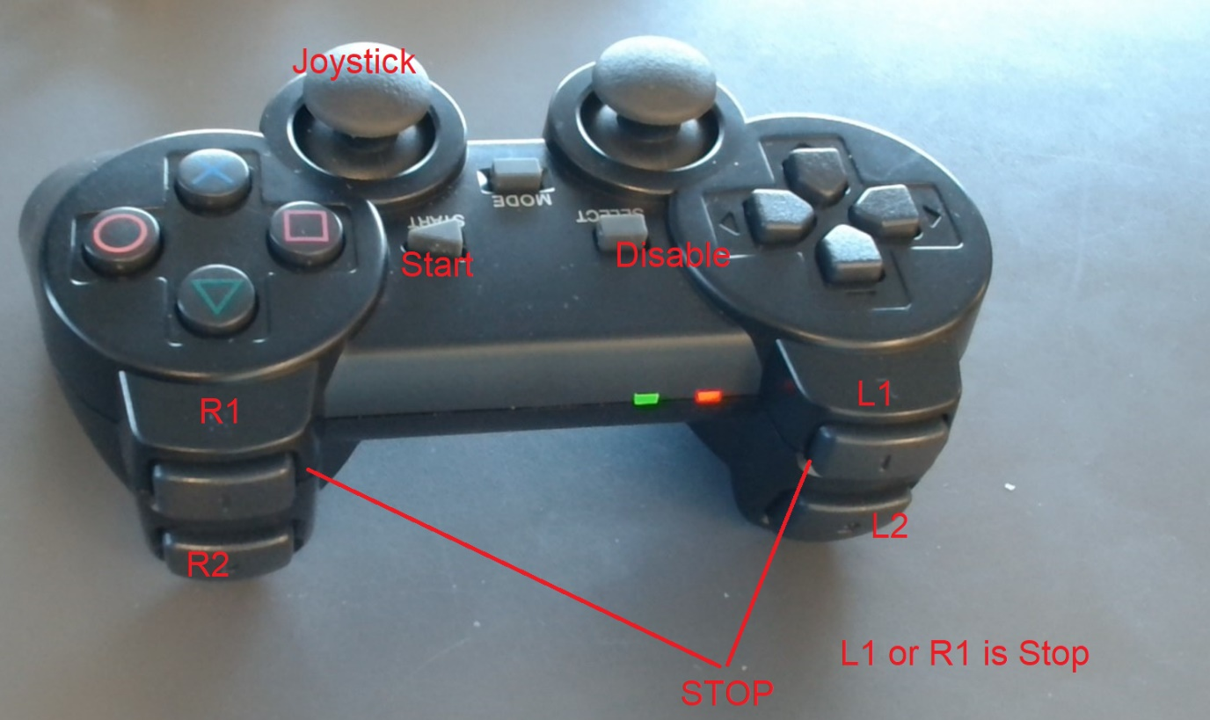

**4. Operate by Webserver on ESP32**

**Make sure pc connected to the same WIFI as Nicobot.**

Use link: <http://192.168.0.100>

Then control the robot car

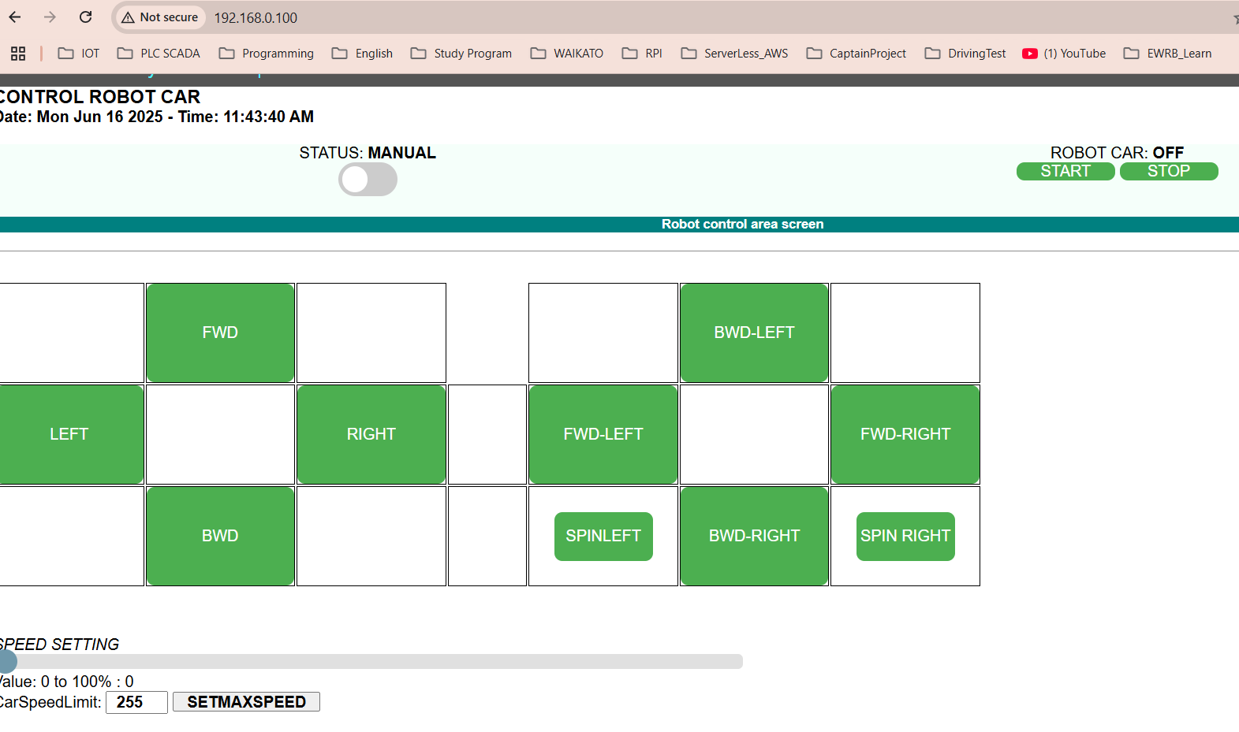

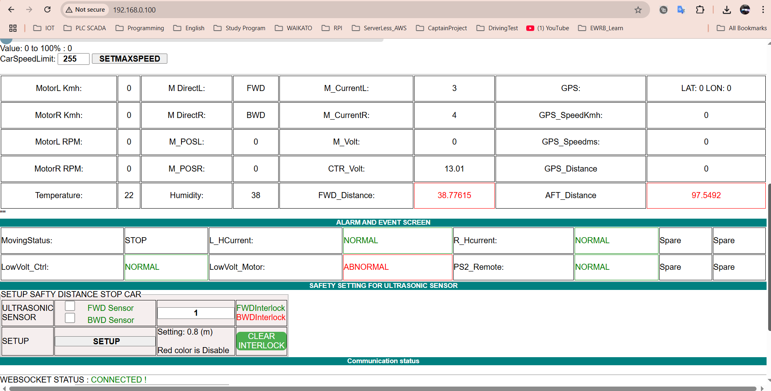

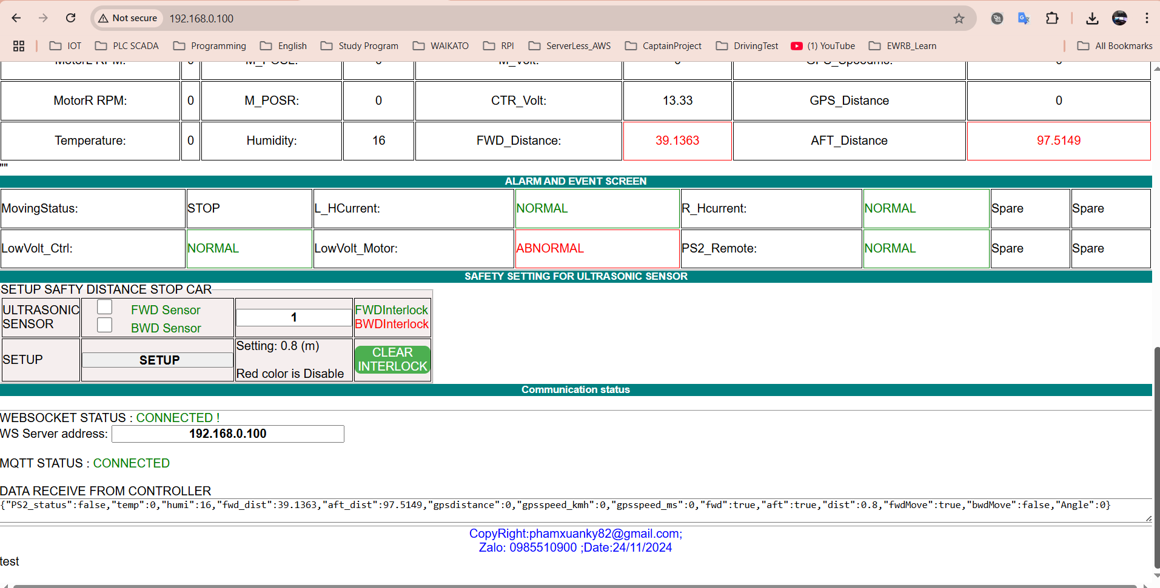

**5. Operate by Webserver on RPI**

**Use the link :** [**http://192.168.0.110/robotweb**](http://192.168.0.110/robotweb)

**Robot can be control by Digial Push button or Joystick**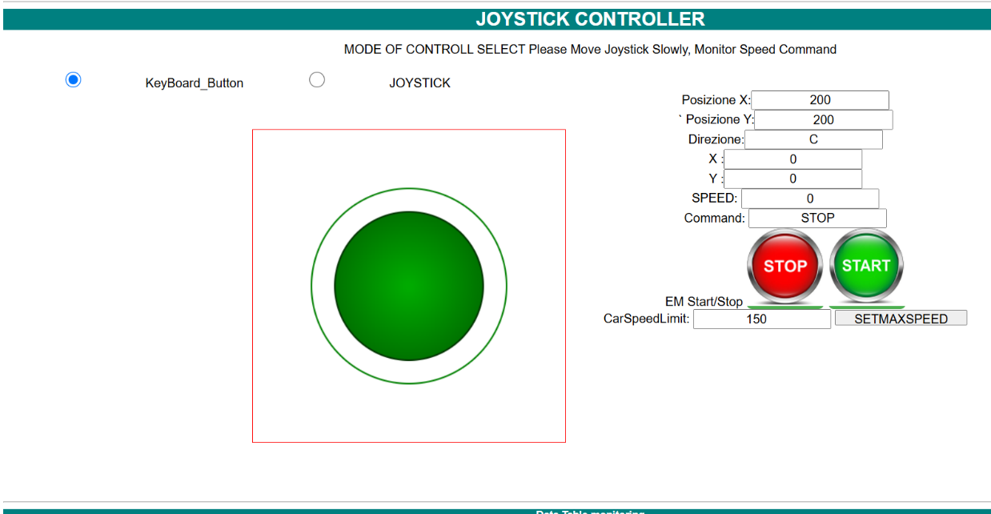

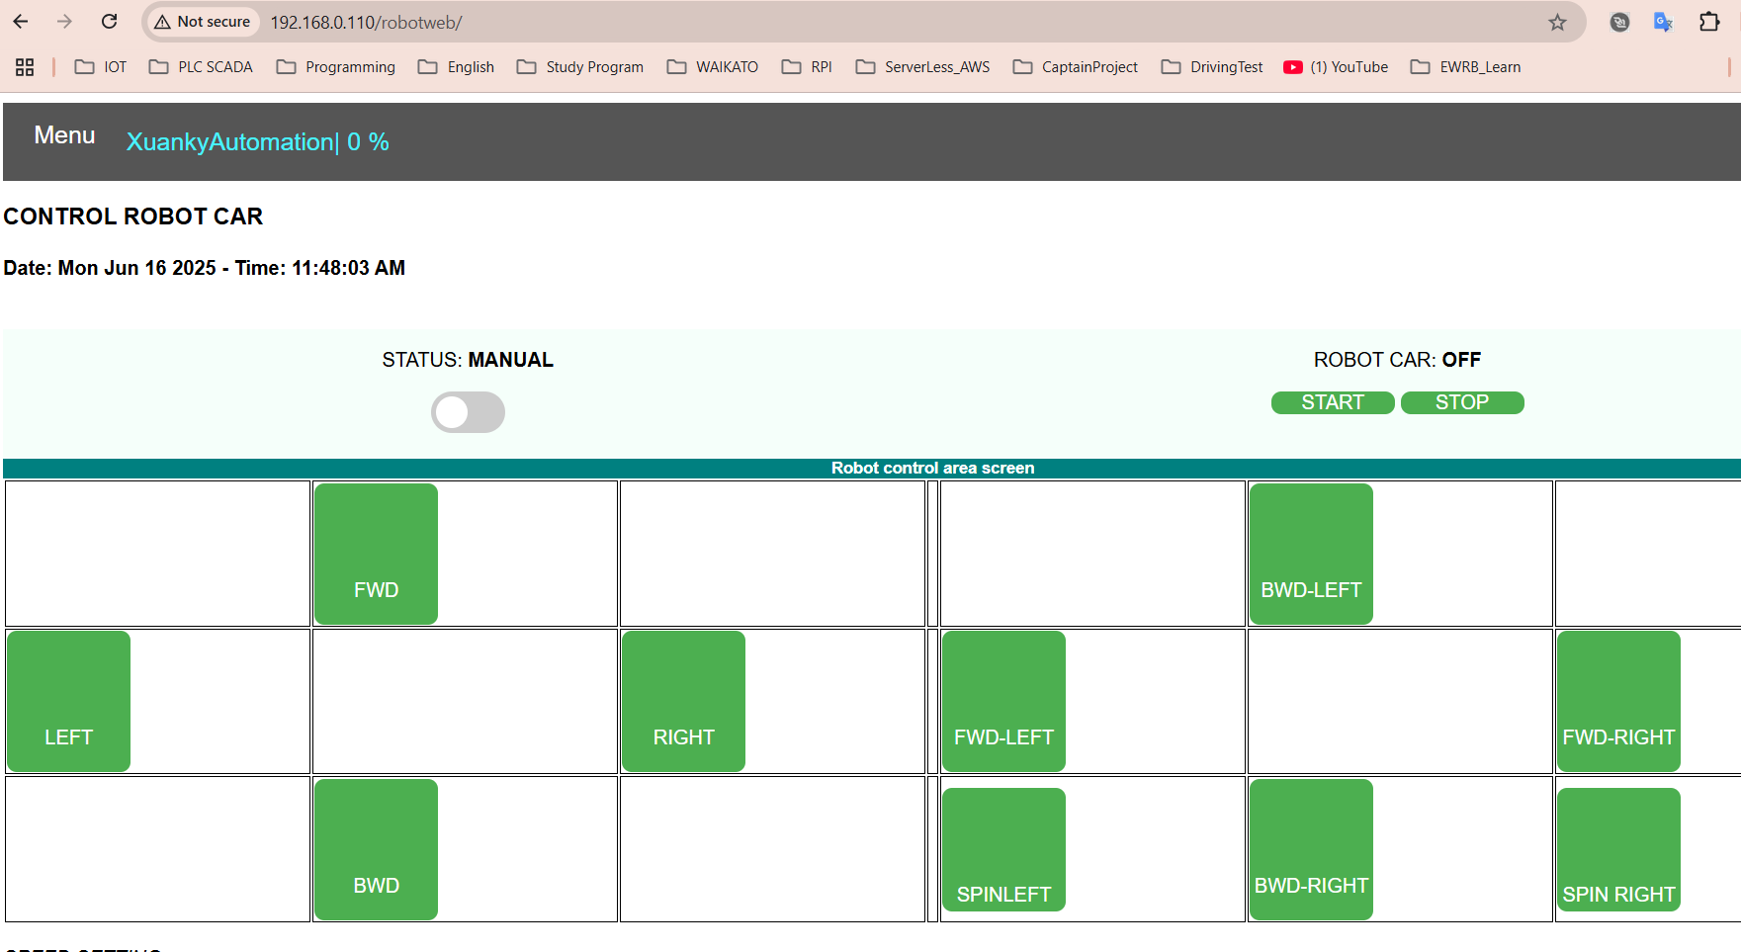

**Click Connect Local Broker**

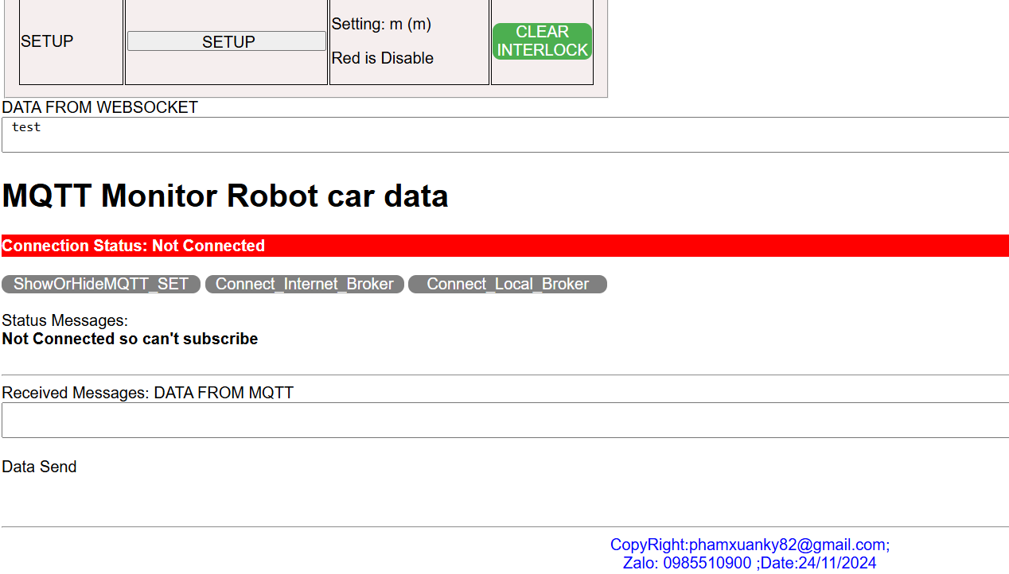

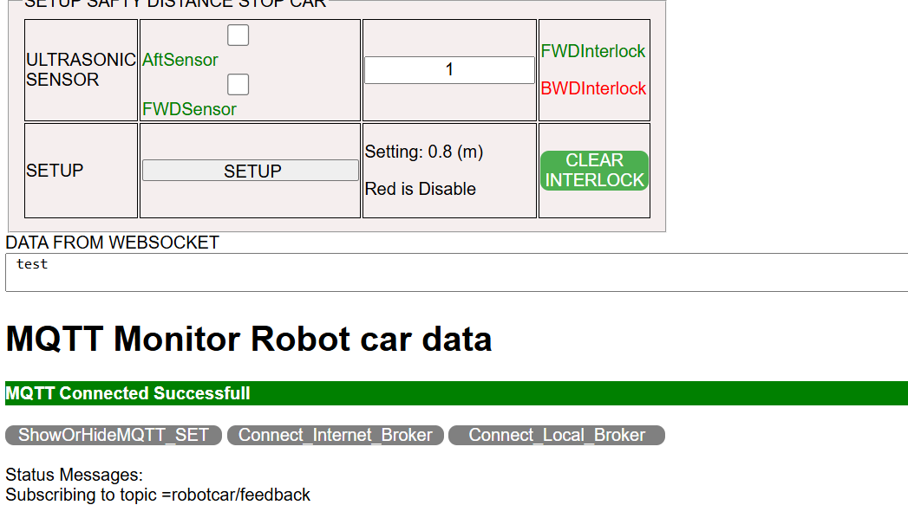

**6. Operate by Python application PY3.11 with PYQT6, Display camera**

2 cameras connected with laptop USB connectors

Run Camera server intel Realsense viewer before operate or click start VIDEO FWD on the Python Screen otherwise error happened.

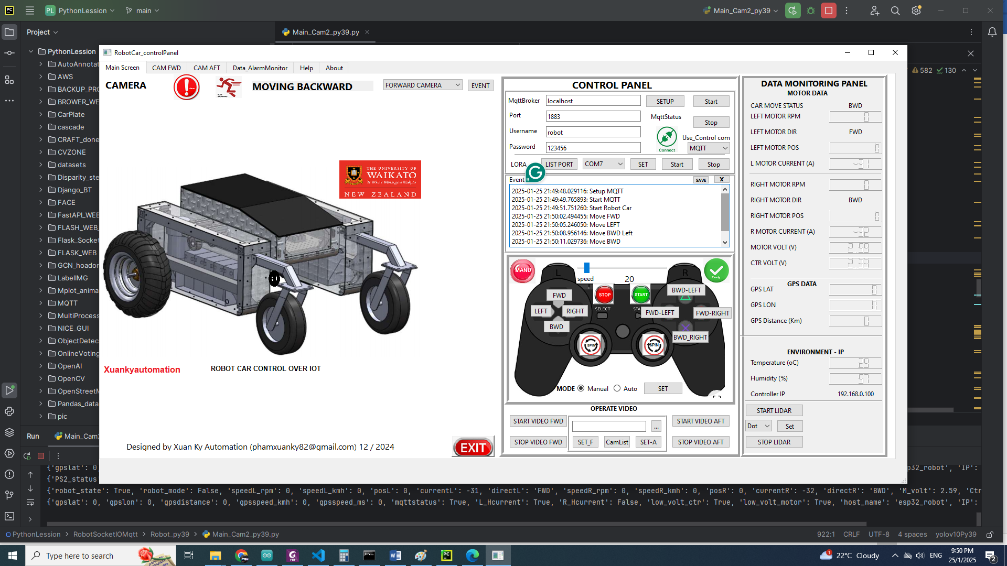

**7. Operate By Python Application with Flask Web Framework, Display camera.**

If use MQTT protocol to transfer camera data, you need to set local laptop as a MQTT Broker. FullaalicationV1.py or FullaalicationV2.py can be used. Otherwise, Don’t use these 2 version. Make sure Python 3.9

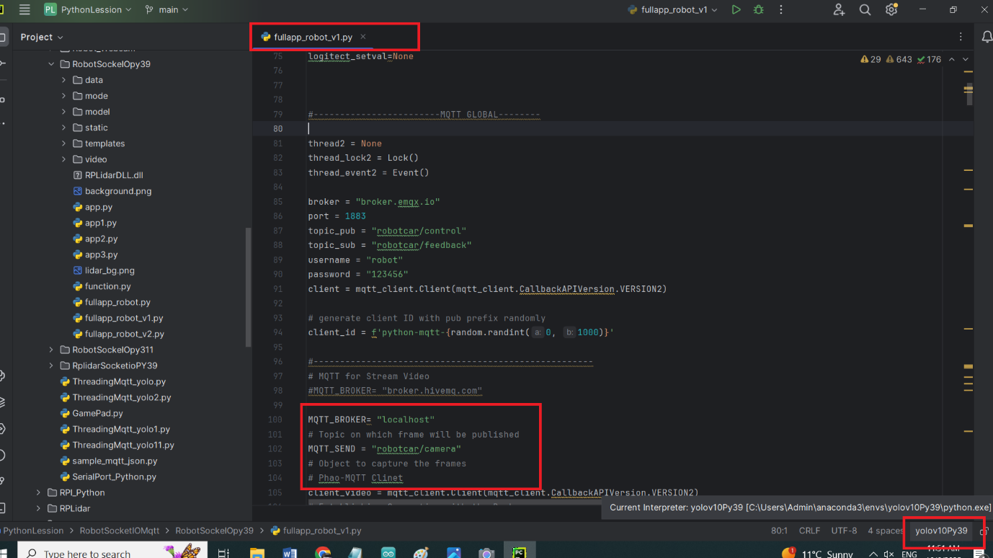

**Fullapplicat.py**

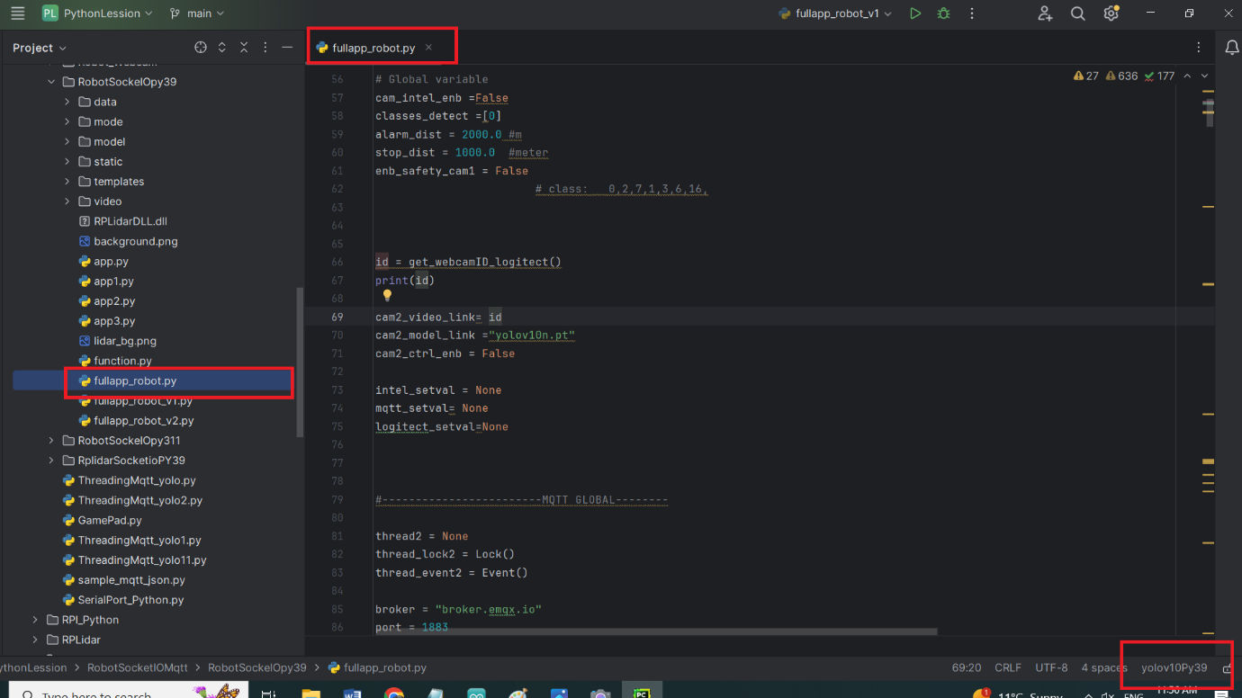

**Run Camra intel realsens viewer.**

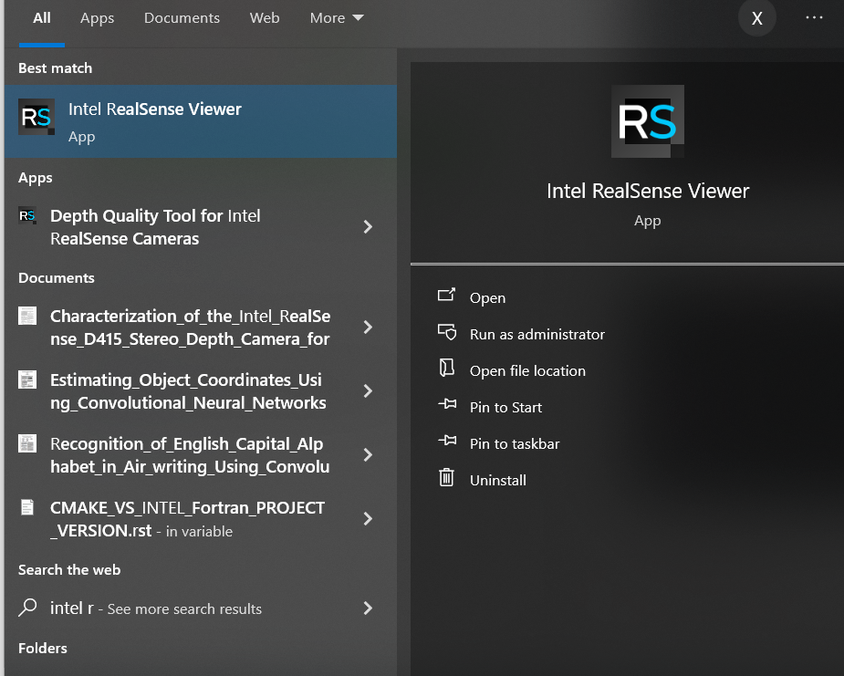

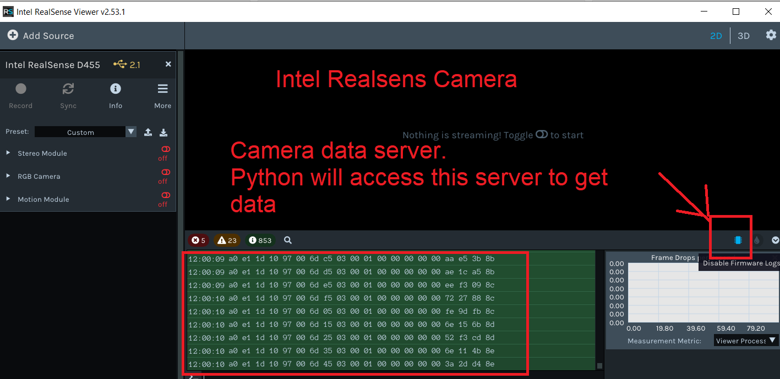

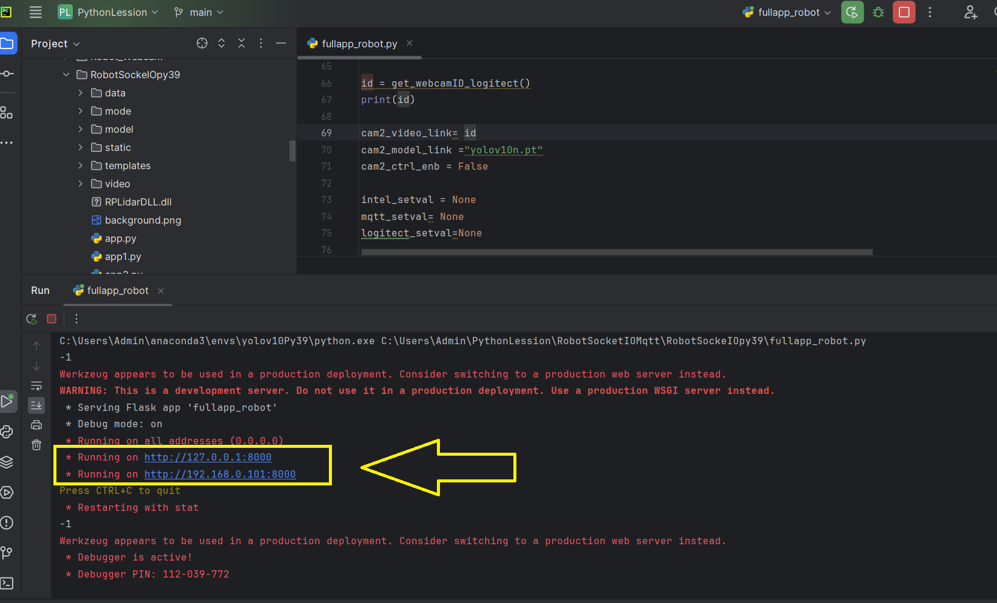

**Click to the link, you will have the same website as RPI above.**

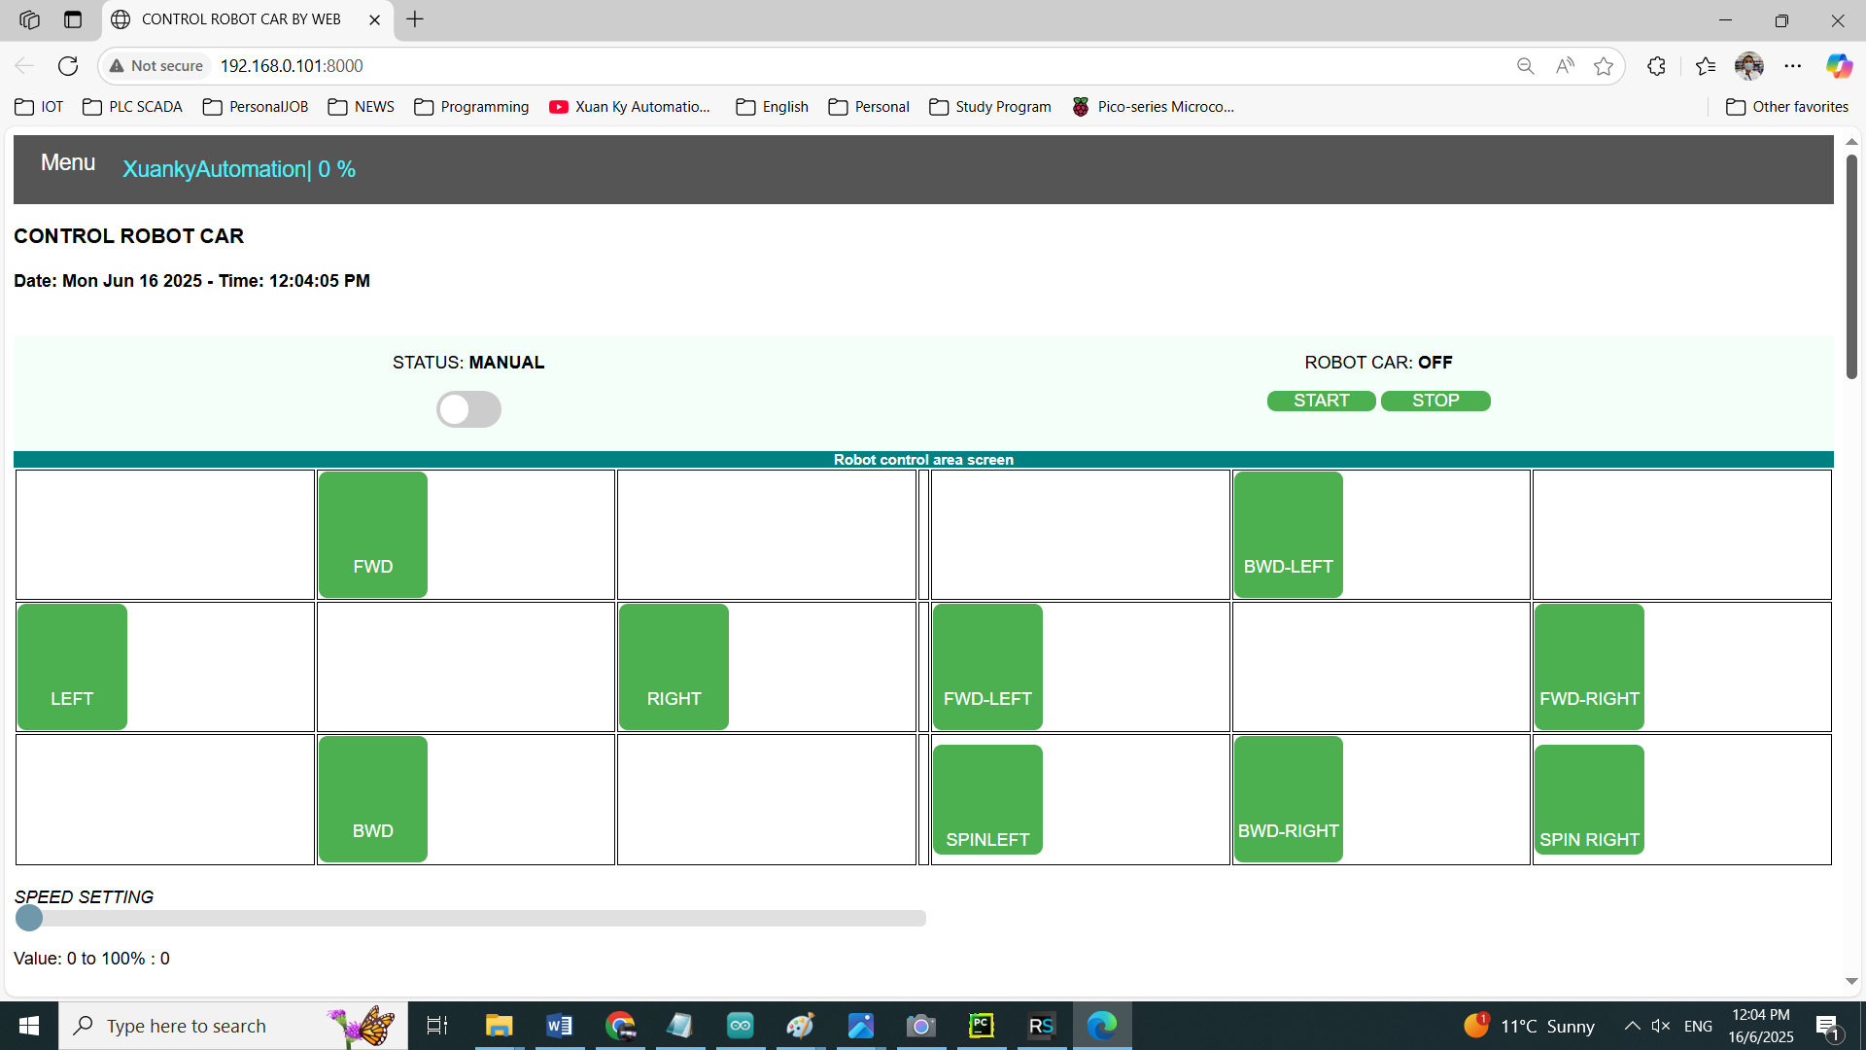

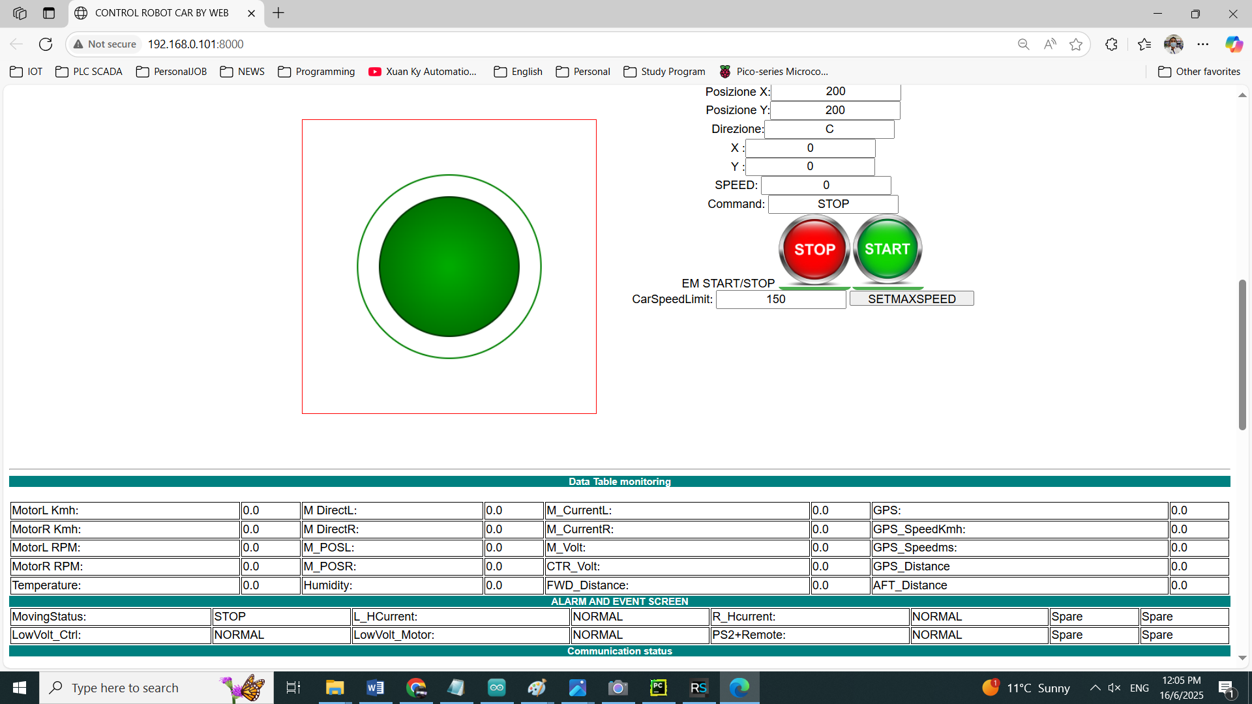

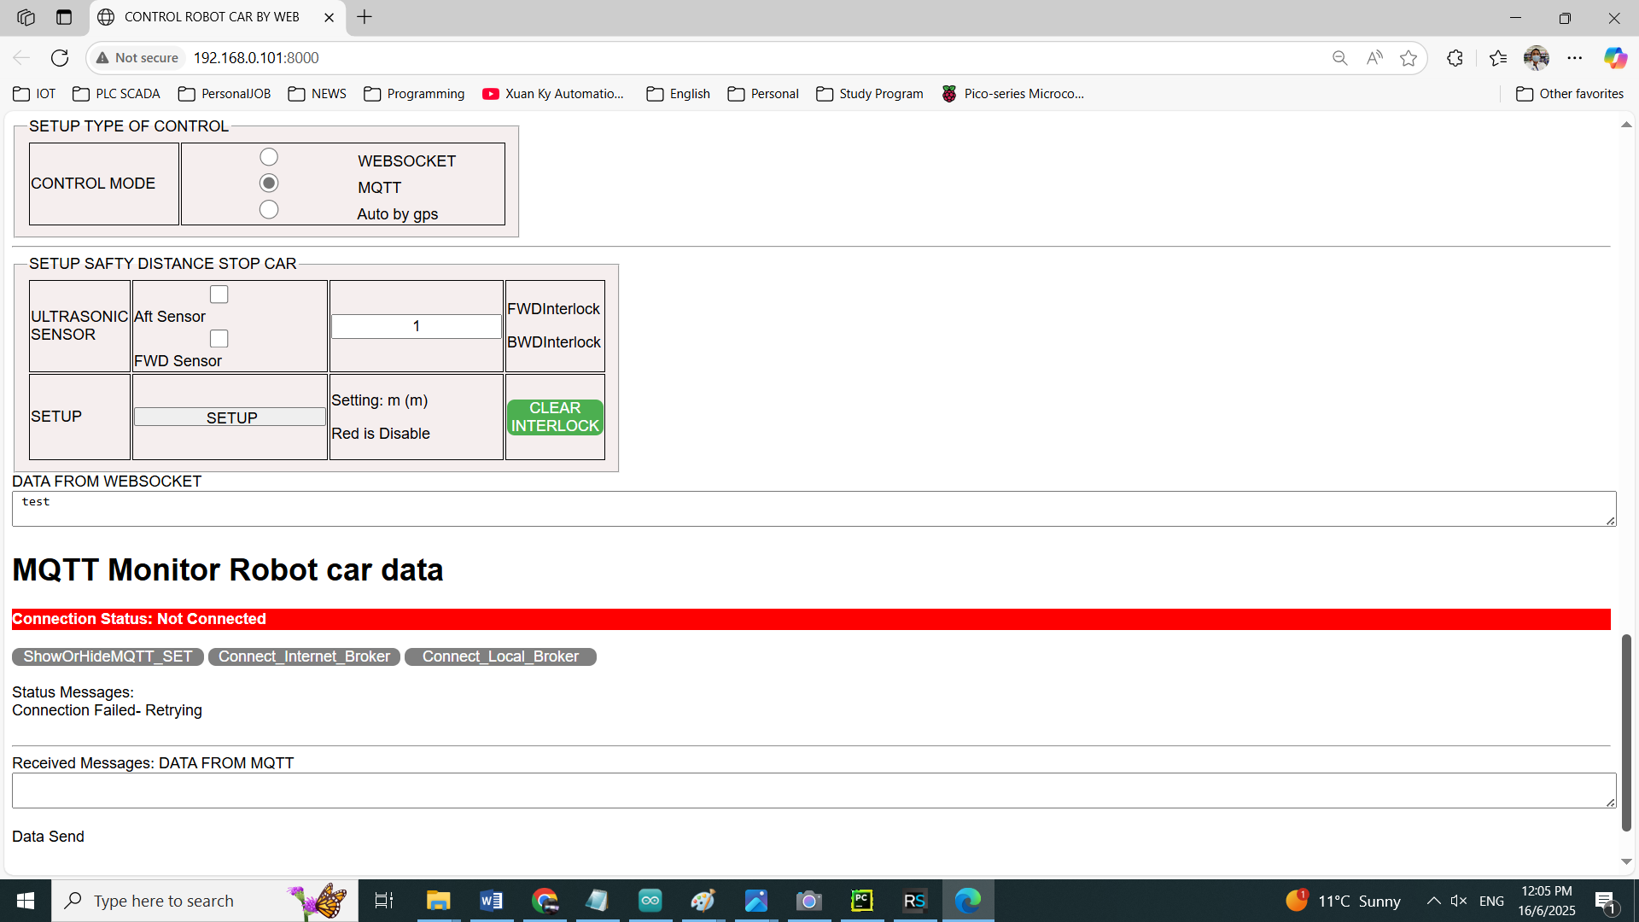

**Click connect Local broker**

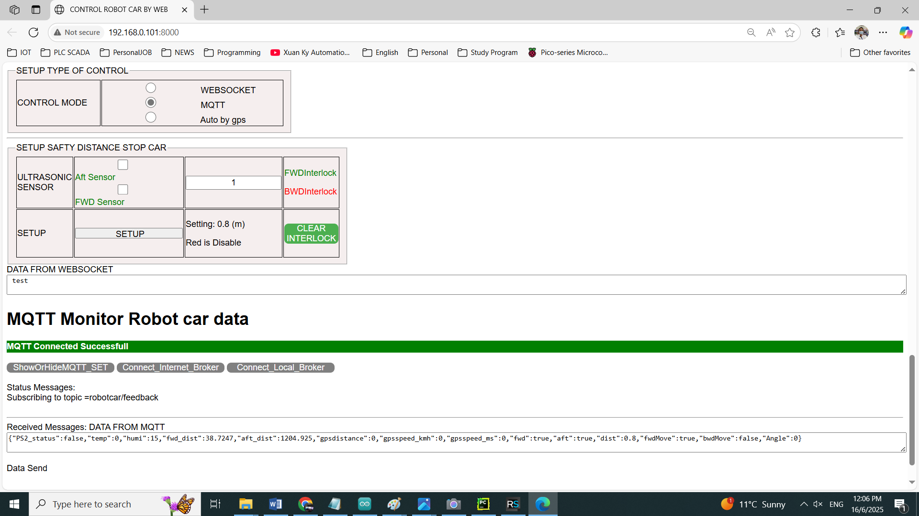

**Now you can operate Robot easily**

**Display 2 cameras.**

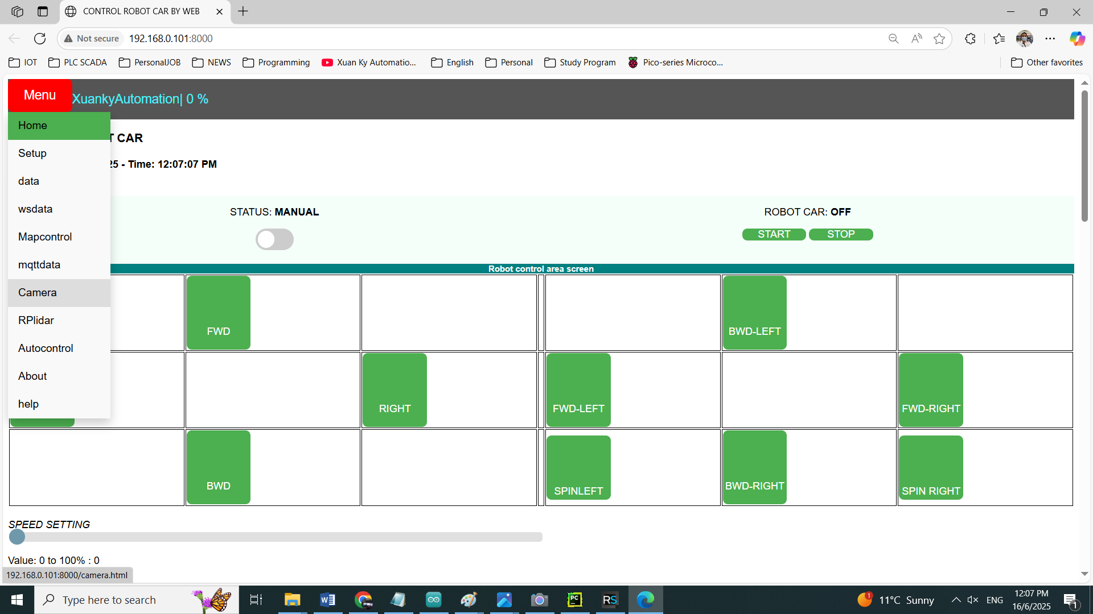

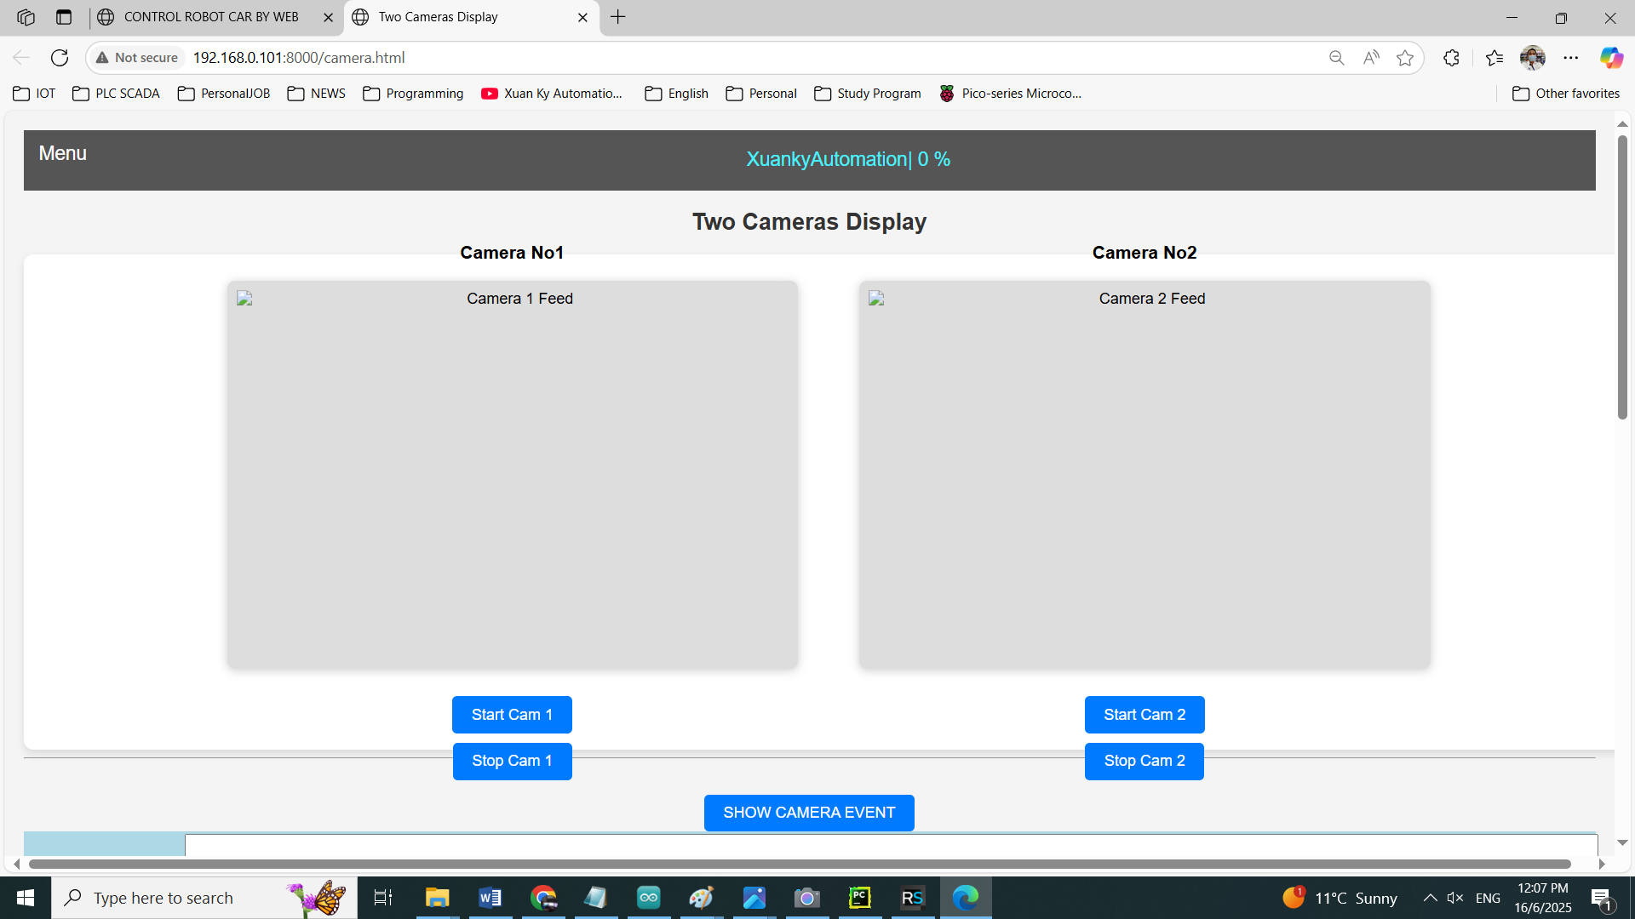

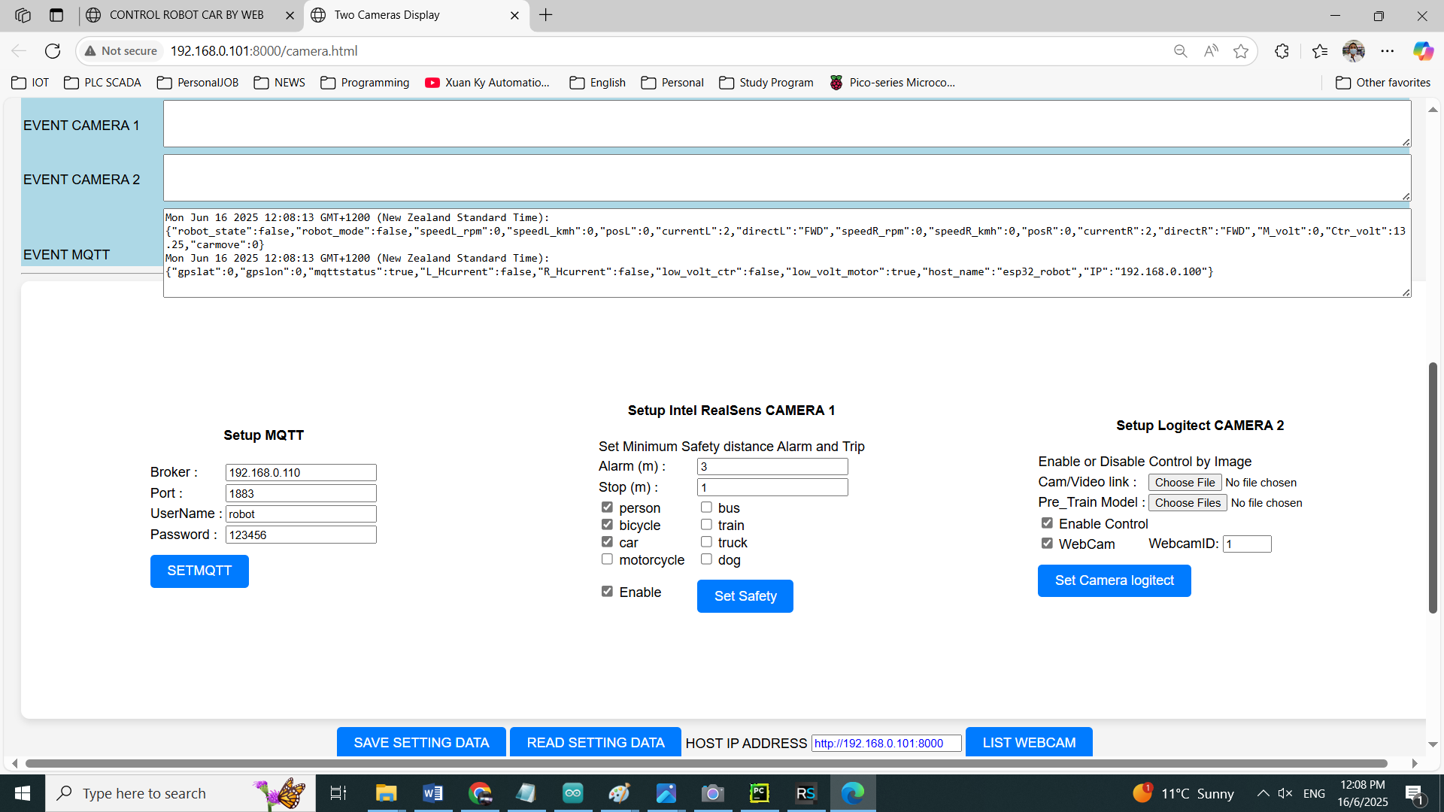

Click the Start CAM1 and Start CAM2 buttons and wait for some time. 2 cameras will display on web website. Logitech will start longer than Intel, because Python reads data of intel from Intel RealSense server, while Python reads data directly from Logitech Camera.

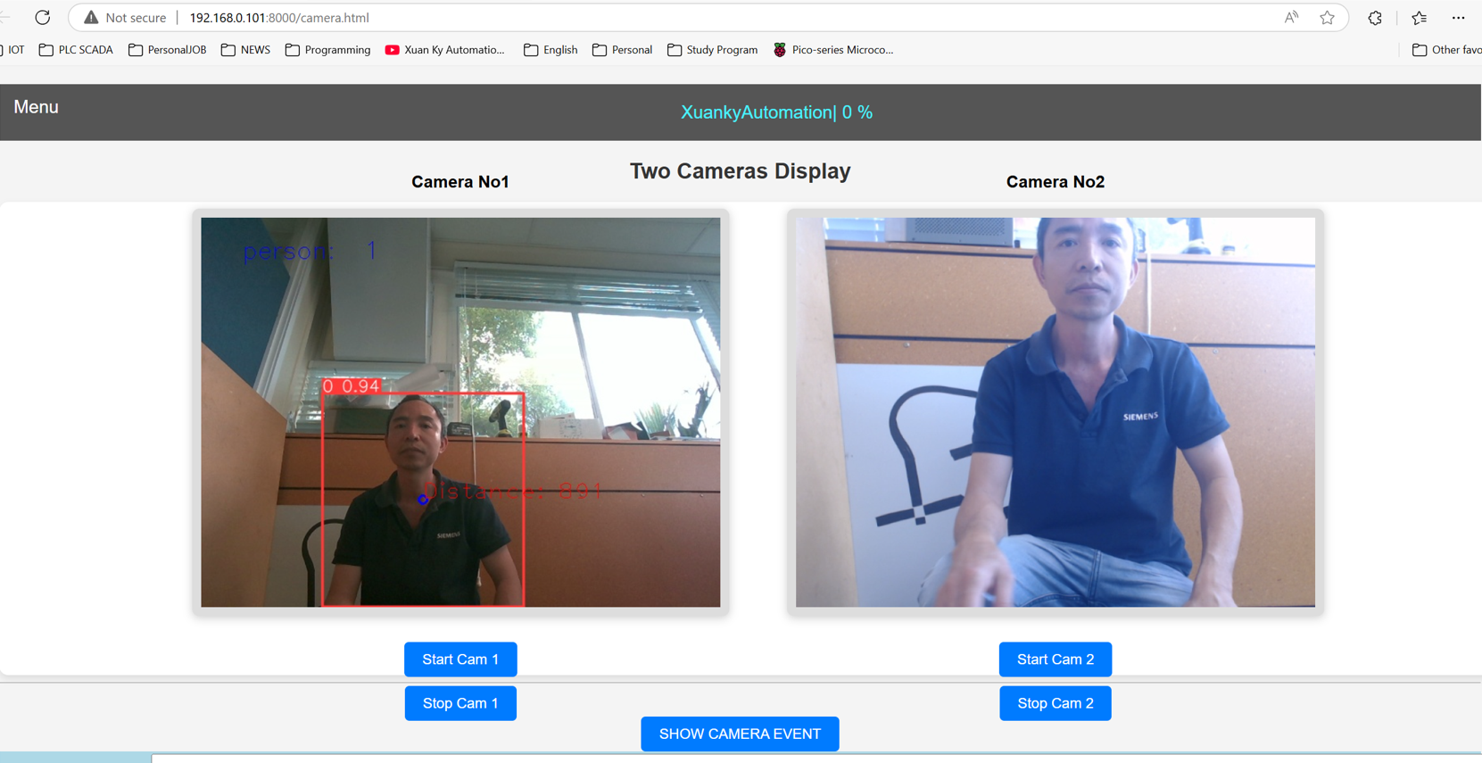

How to Open RPlidar.

Make sure RPlidar connect to USB connector of laptop.

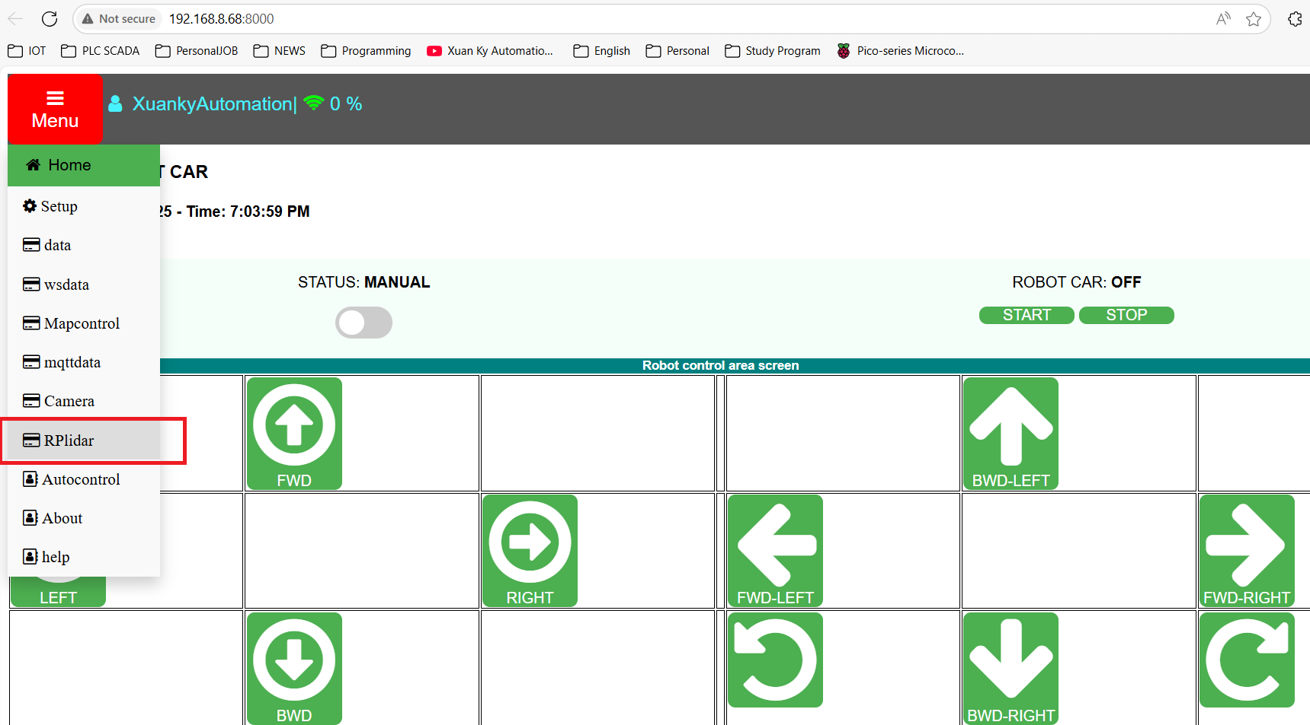

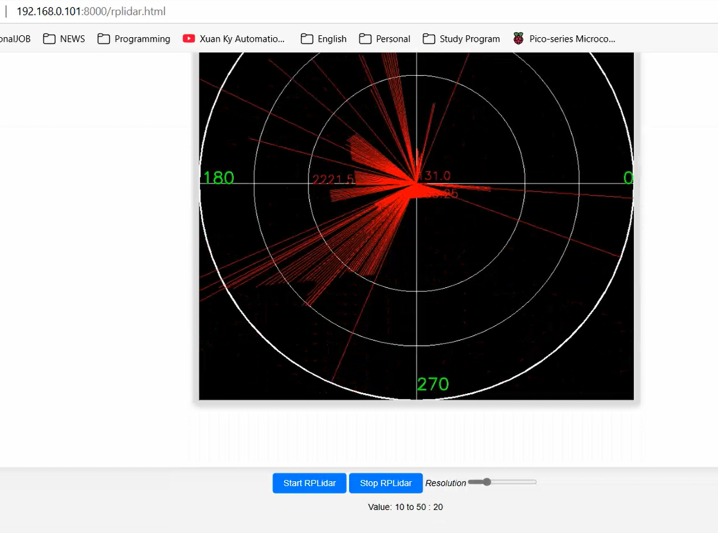

**8. How to change Max Speed of Nicobot**

**Change in ESP32 Web Page.**

[**http://192.168.0.100**](http://192.168.0.100)

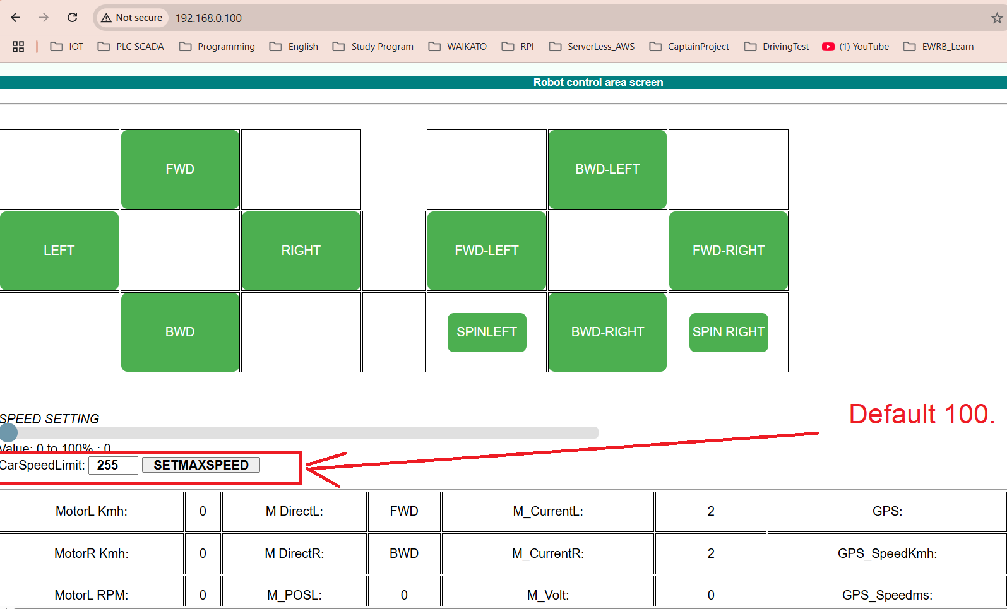

**Change in Other web page.**

**RPI:** [**http://192.168.0.110/robotweb/**](http://192.168.0.110/robotweb/)

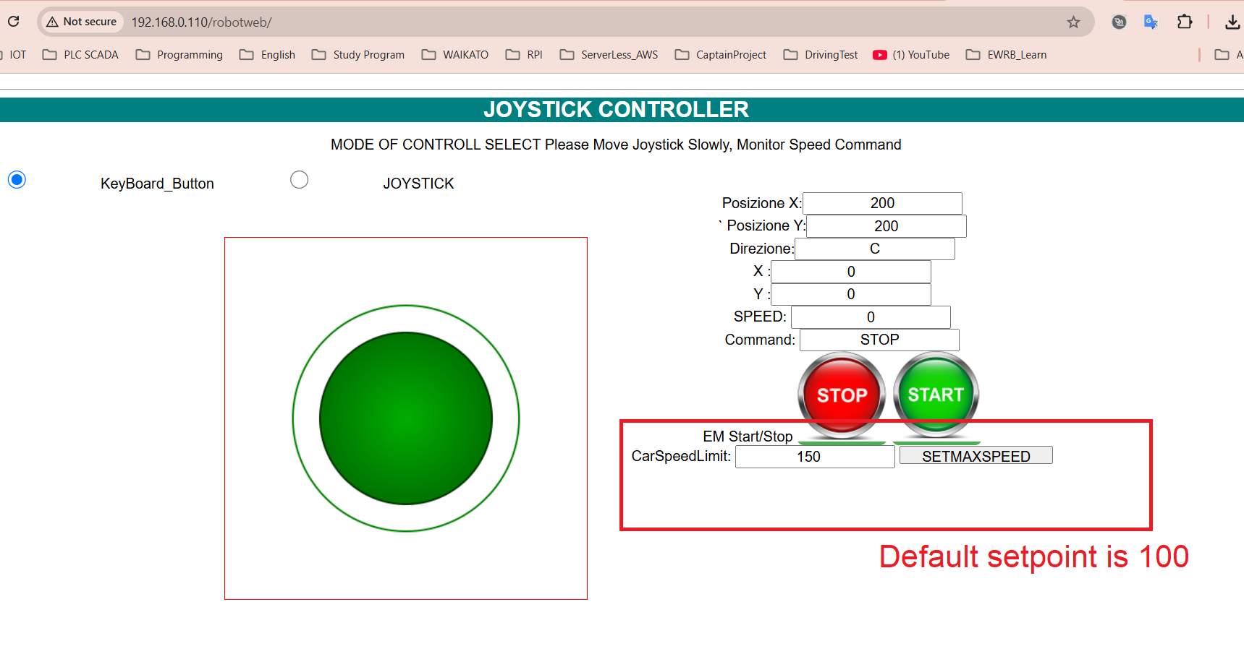

**On MIT Android Application**

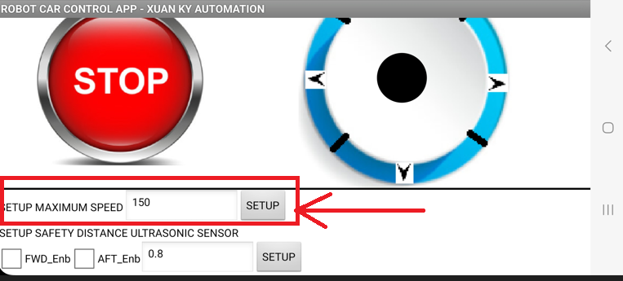

**9.** **How to Disable / Enable FWD and AFT Ultrasonic Sensor**

By an Android application

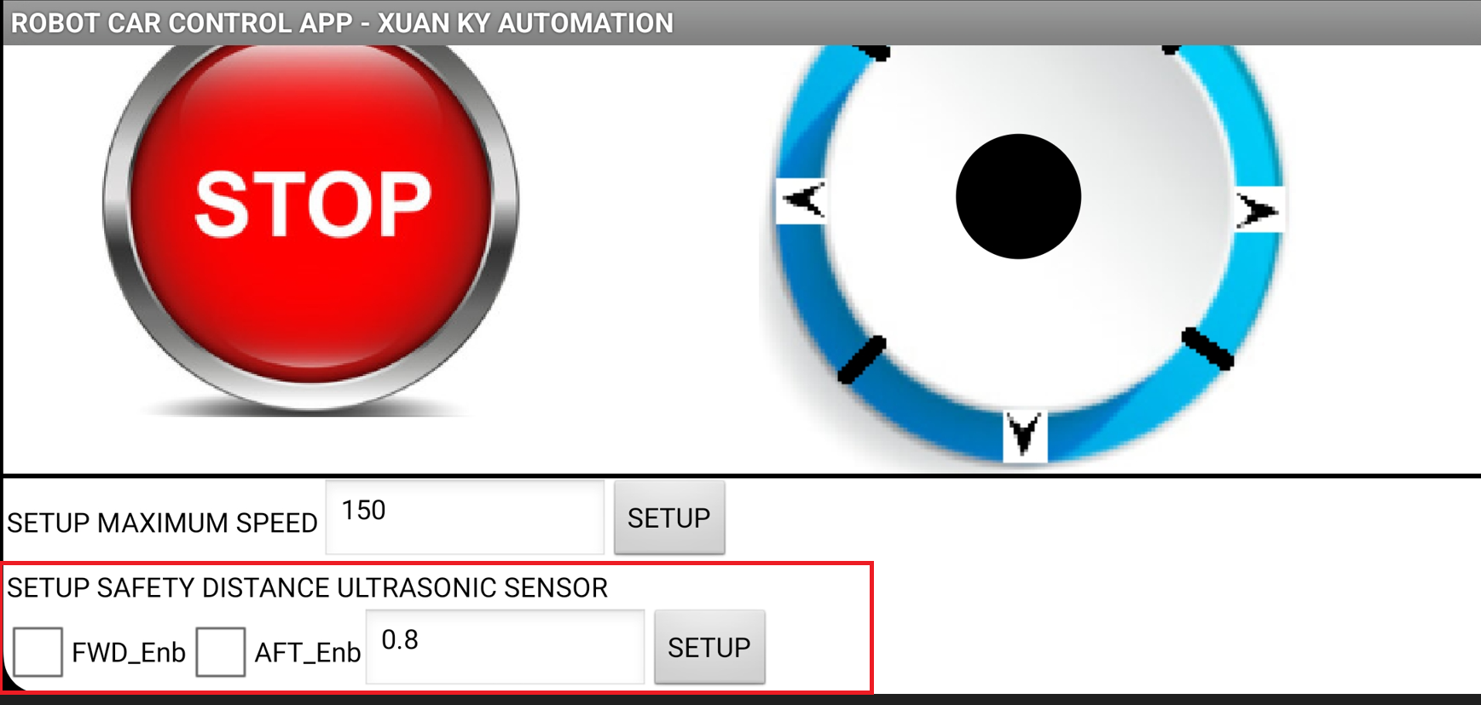

By Web page on RPI/ others

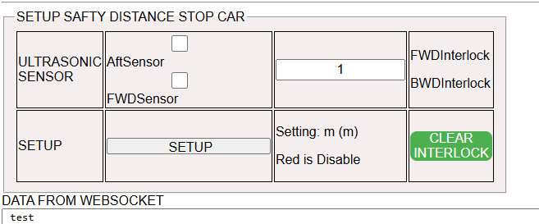

OR

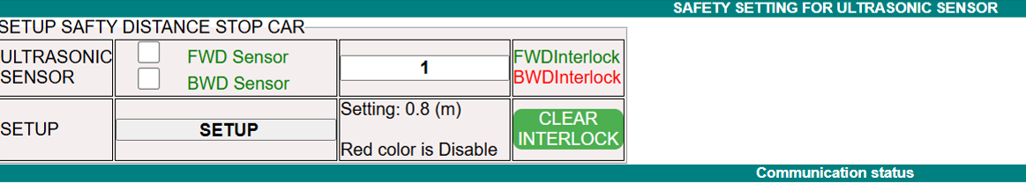

**Disable/Enable Ultrasonic sensor by PS2 Remote**

L2 Button is used to Disable, R2 Button is used to enable the Ultrasonic Sensor.

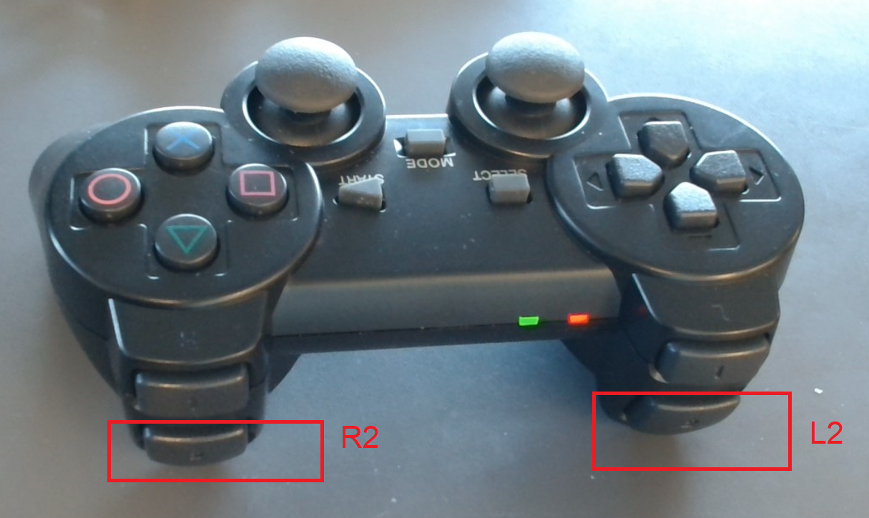

**10. How to Stop Robot car Emergency**

- Press Emergency Push button 1 or switch Motor Battery power to Off position

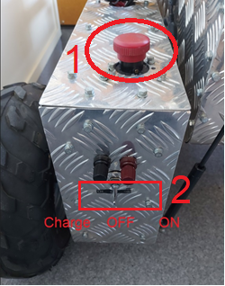

* Press the SELECT button on the Remote PS2 to Stop Emergency or L1 and R1 Button on Remote can set Speed = 0, Car stop;

**11. How to charge Battery for robot car**

- Using Charger

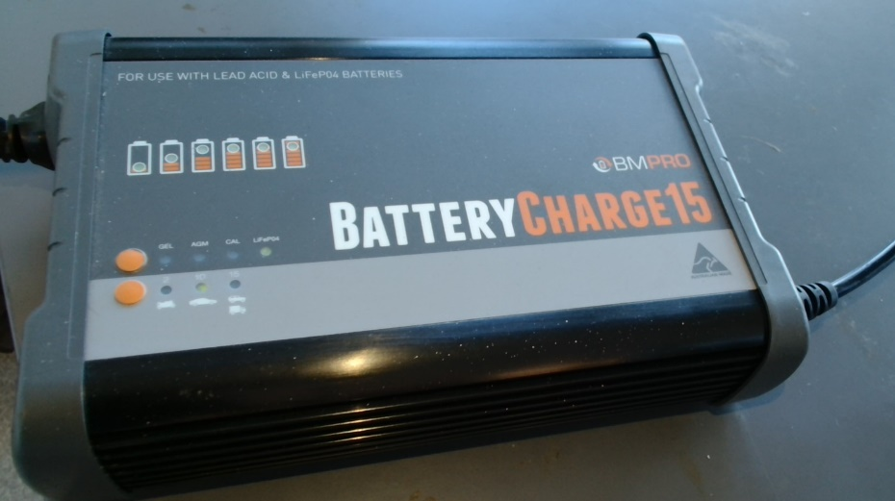

* Charge the control battery 3x12V (7.5Ah x3) 12V battery parallel

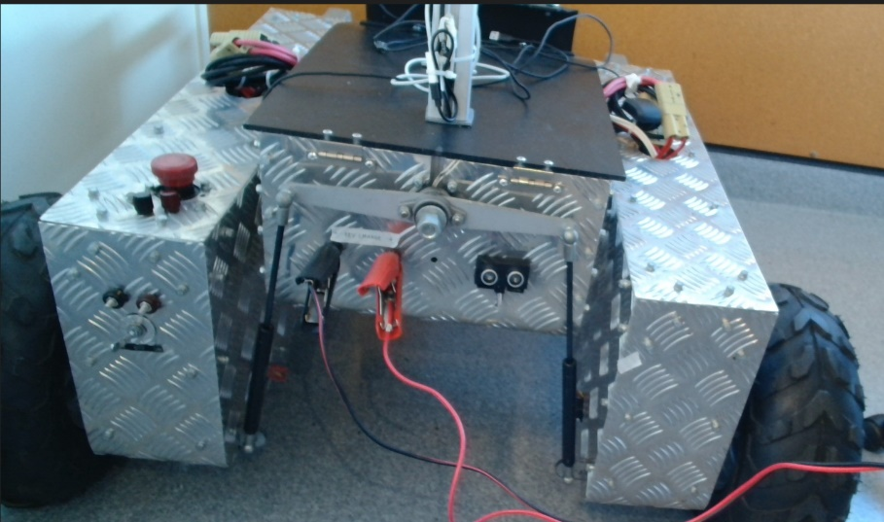

Charge the Motor battery 10 x 12V (7.5Ah x10 ) 12 V battery parallel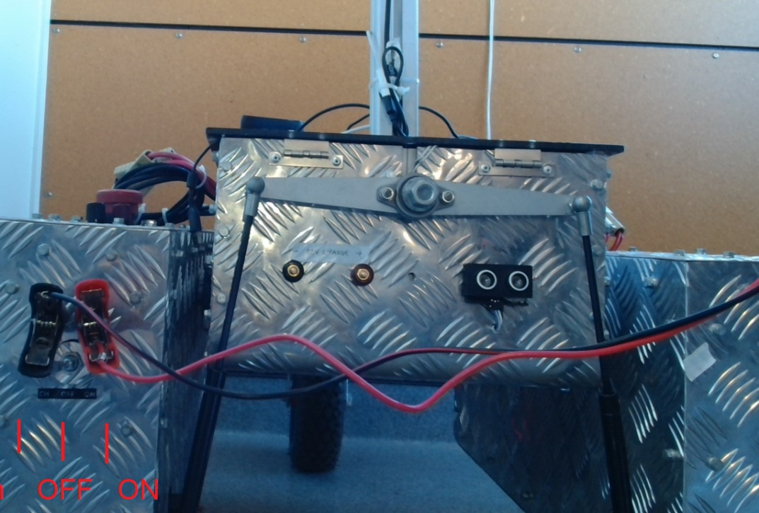

**`12. How to operate by MIT APP**

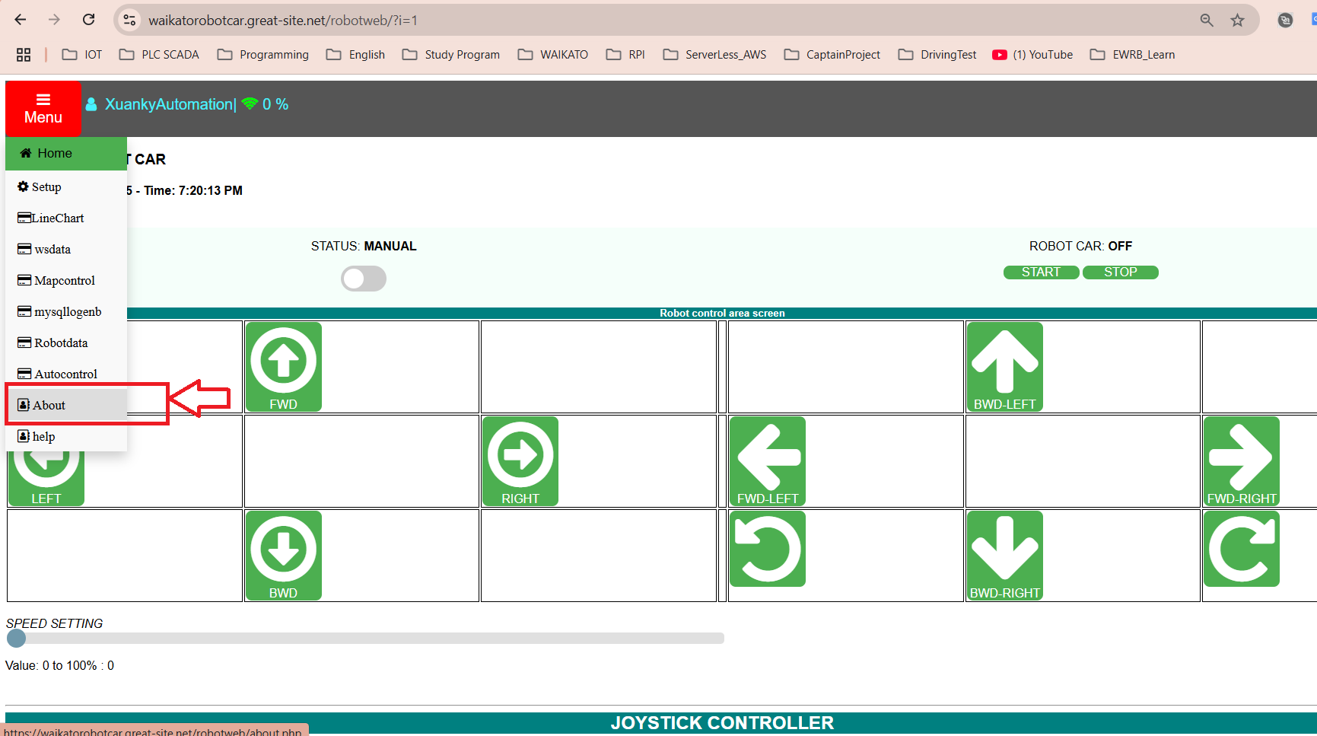

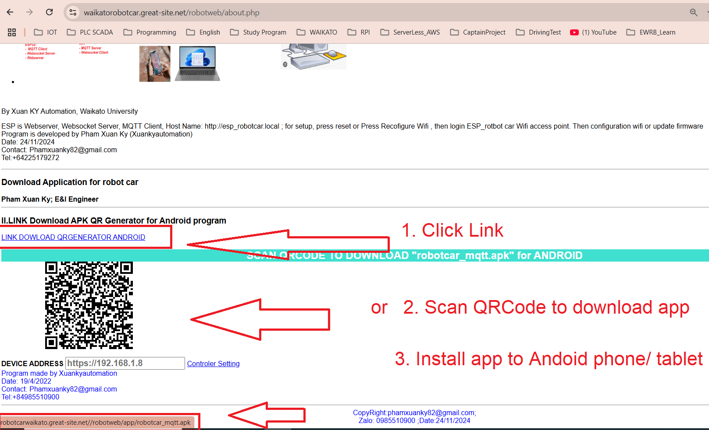

Install to Android phone

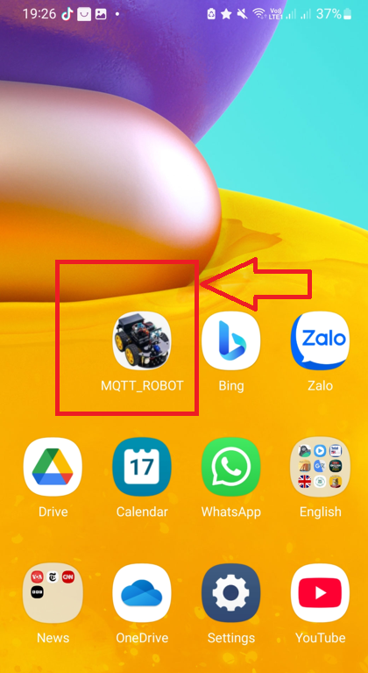

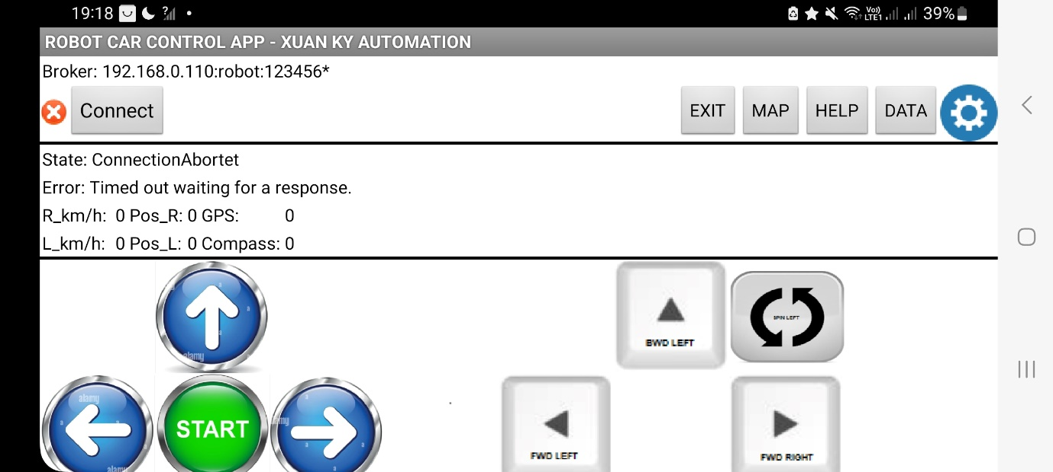

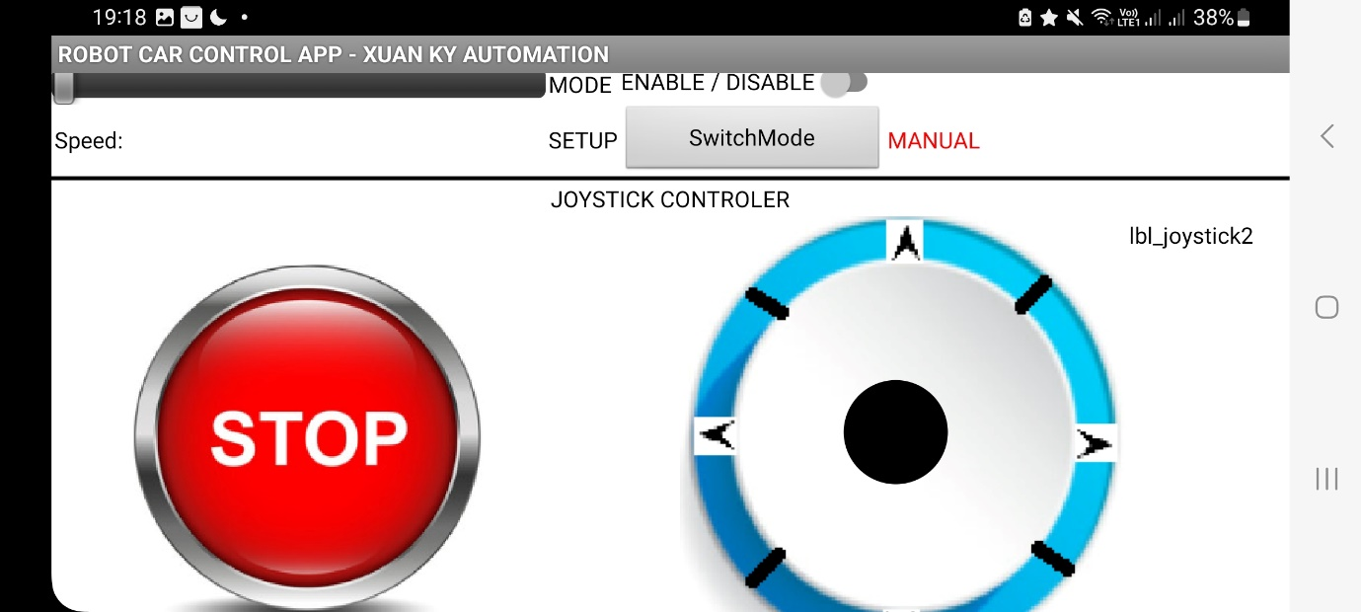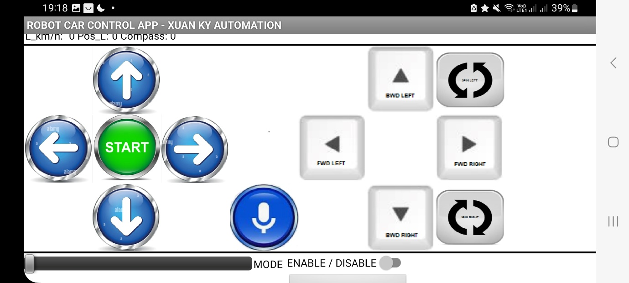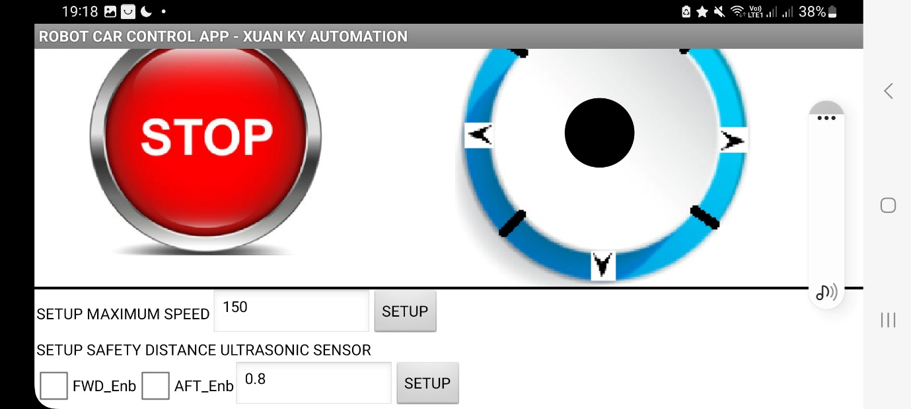

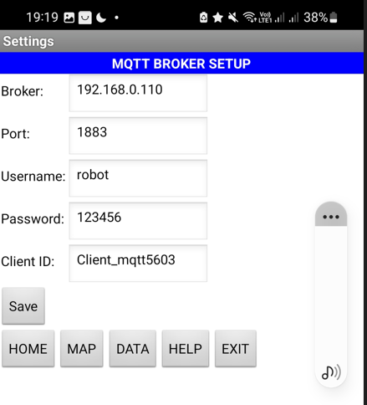

**13. How to setup Wifi when ESP32 not setting or accidentally clear Wifi in ESP32.**

- Power ESP32 ON by switching on the control power inside the control panel

* Use your laptop or smartphone and open the Wi-Fi settings

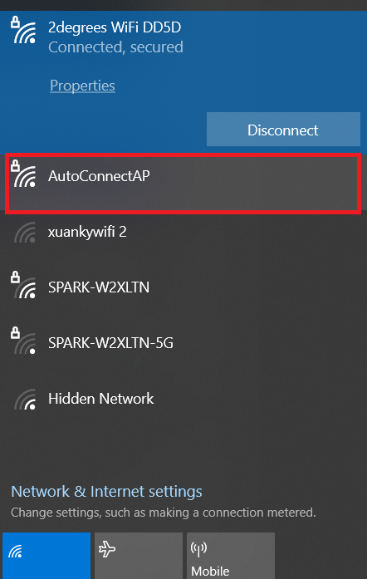

DEFAULT: **User:** AutoCOnnectAP**, PASS:** password

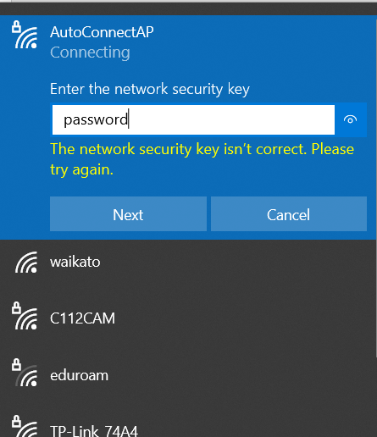

After click connect, computer auto open web to the link : <http://192.168.4.1> If it is not, just open web browser and type manually.

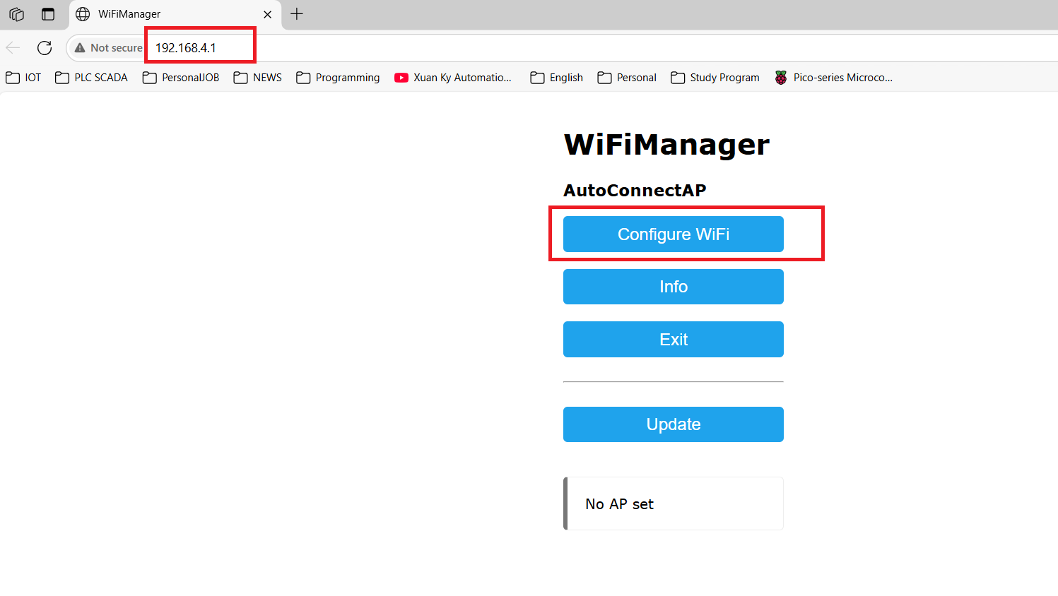

Select Wifi want to connect ( Robot car Robotcar2.4g,, Pass: robotcarky)

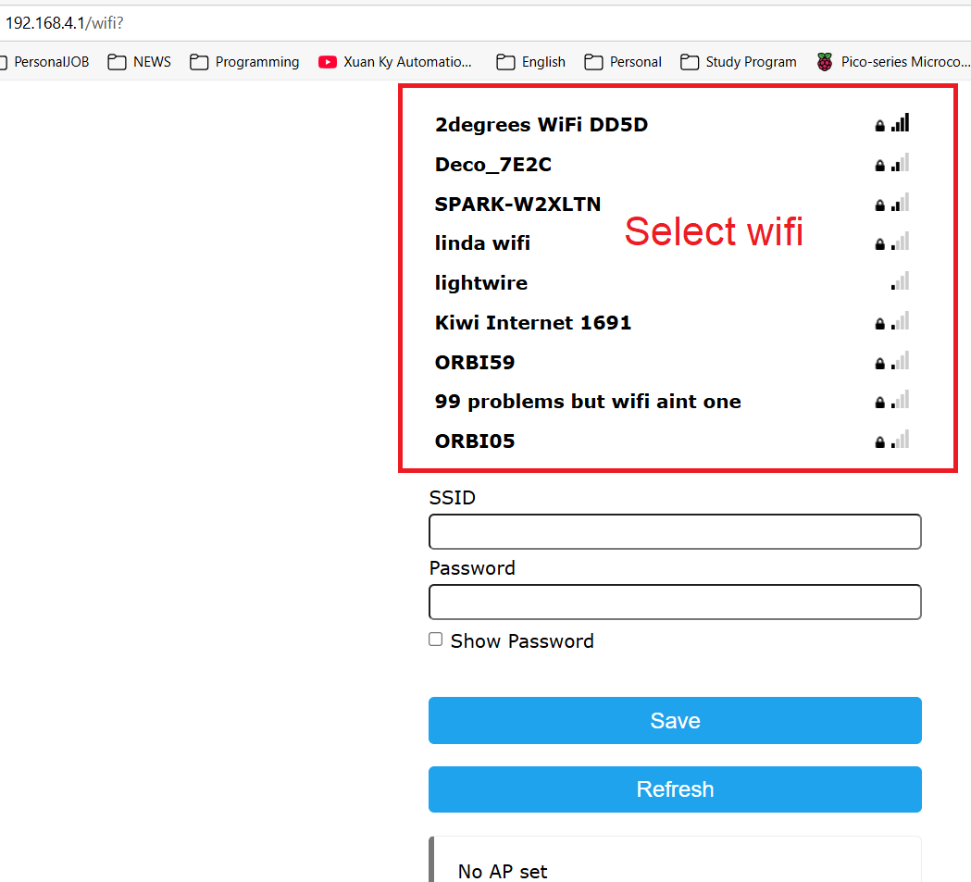

ESP32 auto reset after setting the WiFi

**14. How to clear the Wi-Fi in ESP32 and set up a new wifi router.**

To clear the Wi-Fi, there are 2 ways

* Open the control box and keep pressing the WiFi clear button 5S, ESP33 wifi will be cleared, and go to Step 13 to set wifi.



* Open Web application on ESp32, http:// 192.168.0.100

Click the clear wifi and reset button

ESP32 wifi will be cleared and reset automatically

Follow step 13 to set up wifi.

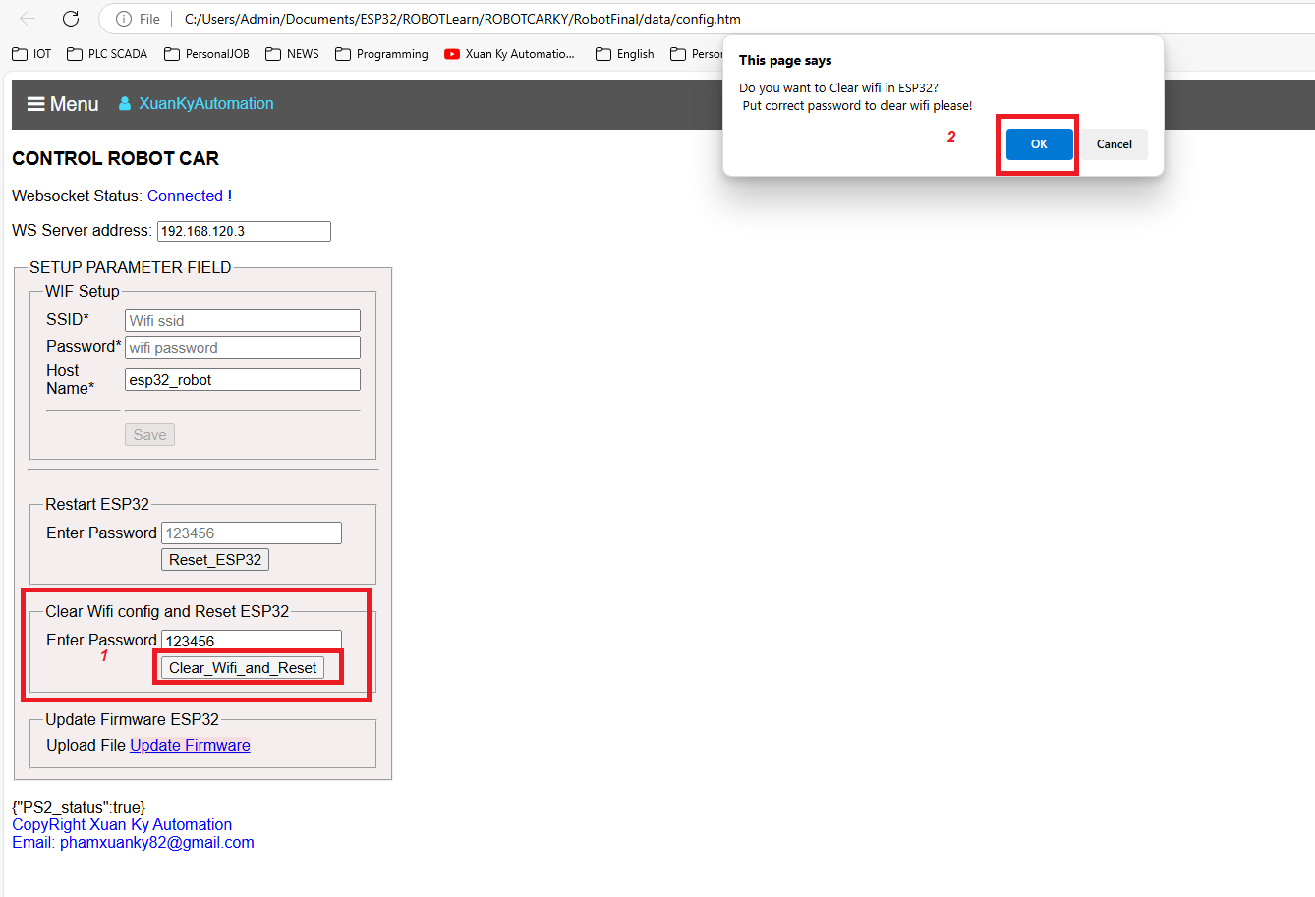

Note: ESP32 Controller is already set up with Wi-Fi, just plug and use it